15. Assessment of the Thornyhead stock complex in the Gulf of Alaska

Katy B. Echave, Peter-John F. Hulson, and Kevin A. Siwicke

November 2020 Plan Team Draft

# Executive Summary

Rockfish have historically been assessed on a biennial stock assessment schedule to coincide with the availability of new trawl survey data (odd years). In 2017, the Alaska Fisheries Science Center (AFSC) participated in a stock assessment prioritization process. It was recommended that the Gulf of Alaska (GOA) thornyhead complex remain on a biennial stock assessment schedule with a full stock assessment produced in even years and no stock assessment produced in odd years.

For this on-cycle year, we incorporate new survey biomass from the 2019 bottom trawl survey, new Relative Population Weights (RPWs) from the 2019 and 2020 longline surveys, and update auxiliary data sources.

This stock is classified as a Tier 5 stock. We continue to use a random effects (RE) model fit to survey data to estimate exploitable biomass and determine the recommended ABC. The RE model was fit to the time series of trawl survey biomass values and estimates of uncertainty by region and depth strata and regional RPW indices from the AFSC longline survey (with associated estimates of uncertainty). These regional biomass estimates from the RE model were then summed to obtain Gulfwide biomass.

## Summary of changes in assessment inputs

#### Changes in the input data

1. Total catch was updated with partial 2020 data through 6 October 2020.
2. Length compositions from the 2018 and 2019 longline and trawl fisheries were added.
3. Length compositions from the 2019 GOA bottom trawl survey data were added.
4. Relative Population Numbers (RPNs), RPWs, and length compositions from the 2018, 2019, and 2020 AFSC annual longline surveys were updated.
5. RPWs from the 1992 – 2020 GOA longline survey were updated for use in the random effects model.
6. Biomass values from the 1984 – 2019 GOA trawl surveys were updated for use in the random effects model.

#### Changes in assessment methodology

There were no changes to assessment methodology.

## Summary of results

For the 2021 fishery, we recommend the maximum allowable ABC of 1,953 t for thornyhead rockfish. This ABC is a decrease of 3.1% from the 2020 ABC of 2,016 t. The OFL is 2,604 t. Reference values for thornyhead rockfish are summarized in the following table, with the recommended ABC and OFL values in bold. The stock was not being subjected to overfishing last year.

|  |  |  |  |  |  |  |
| --- | --- | --- | --- | --- | --- | --- |
| **Quantity** | As estimated or  specified last year for: | | | As estimated or  recommended this year for: | | |
| 2020 | 2021 | | 2021 | 2022 | |
| *M* (natural mortality rate) | 0.03 | 0.03 | | 0.03 | 0.03 | |
| Tier | 5 | 5 | | 5 | 5 | |
| Biomass (t) | 89,609 | 89,609 | | 86,802 | 86,802 | |
| FOFL | *F=M=*0.03 | *F=M=*0.03 | | *F=M=*0.03 | *F=M=*0.03 | |
| maxFABC | 0.75*M*=0.0225 | 0.75*M*=0.0225 | | 0.75*M*=0.0225 | 0.75*M*=0.0225 | |
| FABC | 0.0225 | 0.0225 | | 0.0225 | 0.0225 | |
| OFL (t) | 2,688 | 2,688 | | **2,604** | 2,604 | |
| maxABC (t) | 2,016 | 2,016 | | 1,953 | 1,953 | |
| ABC(t) | 2,016 | 2,016 | | **1,953** | 1,953 | |
| Status | As determined *last* year for: | | | As determined *this* year for: | | |
|  | 2018 | | 2019 | 2019 | | 2020 |
| Overfishing | No | | n/a | No | | n/a |

Updated catch data (t) for thornyhead rockfish in the GOA as of October 6, 2020 (NMFS Alaska Regional Office Catch Accounting System via the Alaska Fisheries Information Network (AKFIN) database, <http://www.akfin.org>) are summarized in the following table.

|  |  |  |  |  |  |  |
| --- | --- | --- | --- | --- | --- | --- |
| Year | Western | Central | Eastern | Gulfwide Total | Gulfwide ABC | Gulfwide TAC |
| 2019 | 127 | 383 | 267 | 777 | 2,016 | 2,016 |
| 2020 | 49 | 196 | 173 | 418 | 2,016 | 2,016 |

### Area apportionment

For apportionment of ABC/OFL, the random effects model was fit to area-specific biomass and subsequent proportions of biomass by area were calculated. The following table shows the recommended apportionment, estimated biomass, and ABC value by regulatory area for 2021.

|  |  |  |  |  |
| --- | --- | --- | --- | --- |
|  | Regulatory area | | |  |
|  | Western | Central | Eastern | Total |
| Area Apportionment | 18% | 46.6% | 35.4% |  |
| Estimated Area Biomass (t) | 15,649 | 40,430 | 30,723 | 86,802 |
| Area ABC (t) | 352 | 910 | 691 | 1,953 |
| OFL (t) |  |  |  | 2,604 |

## Summaries for Plan Team

All values are in metric tons.

|  |  |  |  |  |  |  |
| --- | --- | --- | --- | --- | --- | --- |
| **Stock/** | **Year** | **Biomass** | **OFL** | **ABC** | **TAC** | **Catch1** |
| **Assemblage** | 2019 | 89,609 | 2,688 | 2,016 | 2,016 | 777 |
| 2020 | 89,609 | 2,688 | 2,016 | 2,016 | 418 |
| 2021 | 86,802 | 2,604 | 1,953 |  |  |
| 2022 | 86,802 | 2,604 | 1,953 |  |  |

|  |  |  |  |  |  |  |  |  |  |
| --- | --- | --- | --- | --- | --- | --- | --- | --- | --- |
| **Stock/** |  | **2020** | | | | **2021** | | **2022** | |
| **Assemblage** | **Area** | **OFL** | **ABC** | **TAC** | **Catch1** | **OFL** | **ABC** | **OFL** | **ABC** |
| Thornyhead rockfish | W |  | 326 | 326 | 49 |  | 352 |  | 352 |
| C |  | 911 | 911 | 196 |  | 910 |  | 910 |
| E |  | 779 | 779 | 173 |  | 691 |  | 691 |
| Total | 2,688 | 2,016 | 2,016 | 418 | 2,604 | 1,953 | 2,604 | 1,953 |

1Catches updated through October 6, 2020: National Marine Fisheries Service, Alaska Region, Catch Accounting System, accessed via the Alaska Fishery Information Network (AKFIN).

## Responses to SSC and Plan Team comments on assessments in general

*“The SSC requests that all authors fill out the risk table in 2019…”*(SSC, December 2018)

*“…risk tables only need to be produced for goundfish assessments that are in ‘full’ year in the cycle.”*(SSC, June 2019)

*“The SSC recommends the authors complete the risk table and note important concerns or issues associated with completing the table.”*(SSC, October 2019)

*“The Teams recommended that authors continue to fill out the risk tables for full assessments. The Teams recommended that adjustment of ABC in response to levels of concern should be left to the discretion of the author, the Team(s), and/or the SSC, but should not be mandated by the inclusion of a >1 level in any particular category. The Teams request clarification and guidance from the SSC regarding the previously noted issues associated with completing the risk table, along with any issues noted by the assessment authors. The Teams plan to discuss the risk table process at the September meeting.”* **(**Plan Team, Dec 2019).

*“The SSC requests that the GPTs, as time allows, update the risk tables for the 2020 full assessments.*

*…..The SSC recommends dropping the overall risk scores in the tables.*

*…..The SSC requests that the table explanations be included in all the assessments which include a risk table for completeness.*

*….The SSC notes that the risk tables provide important information beyond ABC-setting which may be useful for both the AP and the Council and welcomes feedback to improve this tool going forward.”* (SSC, December 2019)

**As all these comments pertain to the risk table, we combine them in our response. We have constructed the risk table as recommended by the Plan Team and SSC for this year’s full assessment, as detailed in the *Harvest Recommendations* section. After completing this exercise we do not recommend ABC be reduced below maximum permissible ABC.**

## Responses to SSC and Plan Team Comments Specific to this Assessment

*“The SSC supports the PT’s recommendation to process these otoliths in a timely manner such that an age-structured model can be incorporated into future assessments.”* (SSC, Oct 2018)

**The ageing of thornyhead continues to be on hold as there is still no reliable method of ageing these species.**

# Introduction

Thornyheads (*Sebastolobus* species) are groundfish belonging to the family Scorpaenidae, which contains the rockfishes. The family Scorpaenidae is characterized morphologically within the order by venomous dorsal, anal, and pelvic spines, numerous spines in general, and internal fertilization of eggs. While thornyheads are considered rockfish, they are distinguished from the “true” rockfish in the genus *Sebaste*s primarily by reproductive biology; all *Sebastes* rockfish are live-bearing (ovoviviparous) fish, while thornyheads are oviparous, releasing fertilized eggs in floating gelatinous masses. Thornyheads are also differentiated from *Sebastes* in that they lack a swim bladder. There are three species in the genus *Sebastolobus*, including the shortspine thornyhead *Sebastolobus alascanus*, the longspine thornyhead *Sebastolobus altivelis*, and the broadfin thornyhead *Sebastolobus macrochir* (Eschmeyer *et al.* 1983, Love *et al.* 2002).

### General distribution

Thornyheads are distributed in deep water habitats throughout the north Pacific, although juveniles can be found in shallower habitats. The range of the shortspine thornyhead extends from 17 to 1,524 m in depth and along the Pacific Rim from the Seas of Okhotsk and Japan in the western north Pacific, throughout the Aleutian Islands, Bering Sea, Gulf of Alaska (GOA), and south to Baja California in the eastern north Pacific (Love *et al.* 2005). Shortspine thornyheads are considered most abundant from the Northern Kuril Islands to southern California. They are concentrated between 150- and 450-m depths in cooler northern waters, and are generally found in deeper habitats up to 1,000 m in the warmer waters of this range (Love *et al.* 2002).

The longspine thornyhead is found only in the eastern north Pacific, where it ranges from the Shumagin Islands in the GOA south to Baja California. Longspine thornyheads are generally found in deeper habitats ranging from 201-1,756 m (Love *et al.* 2005). They are most commonly found below 500 m throughout their range. Off the California coast, longspine thornyhead is a dominant species in the 500–1,000-m depth range, which is also a zone of minimal oxygen (Love *et al.* 2002).

The broadfin thornyhead is found almost entirely in the western north Pacific, ranging from the Seas of Okhotsk and Japan into the Aleutian Islands and eastern Bering Sea. The depth range of the broadfin thornyhead, 100–1,504 m, is similar to that of the shortspine thornyhead. The broadfin thornyhead is relatively uncommon in the eastern north Pacific, and some researchers believe that historical records of this species from the Bering Sea may have been misidentified shortspine thornyheads.

### Life history information

Shortspine thornyhead spawning takes place in the late spring and early summer, between April and July in the GOA and between December and May along the U.S. west coast. It is unknown when longspine thornyheads spawn in the Alaskan portion of their range, although they are reported to spawn between January and April on the U.S. West coast (Pearson and Gunderson 2003). Unlike rockfish in the genus *Sebastes*, which retain fertilized eggs internally and release hatched, fully developed larvae, thornyheads spawn a bi-lobed mass of fertilized eggs which floats in the water column (Love *et al.* 2002). Once the pelagic egg masses hatch, larval and juvenile thornyheads spend far more time in a pelagic life stage than the young-of-year rockfish in the genus *Sebastes* (Love *et al.* 2002). Shortspine thornyhead juveniles spend 14­–15 months in a pelagic phase, and longspine thornyhead juveniles are pelagic even longer, with up to 20 months passing before they settle into benthic habitat. While shortspine thornyhead juveniles tend to settle into relatively shallow benthic habitats between 100 and 600 m and then migrate deeper as they grow, longspine thornyhead juveniles settle out into adult longspine habitat depths of 600 to 1,200 m.

Once in benthic habitats, both shortspine and longspine thornyheads associate with muddy/hard substrates, sometimes near rocks or gravel, and distribute themselves relatively evenly across this habitat, appearing to prefer minimal interactions with individuals of the same species. Research focusing on non-trawlable habitats found rockfish species often associate with biogenic structure (seafloor relief; Du Preez and Tunnicliffe 2011, Laman *et al.* 2015), and that thornyhead rockfish are often found in both trawlable and untrawlable habitats (Rooper and Martin 2012, Rooper *et al*. 2012). Several of these studies are notable as results indicate adult thornyhead biomass may be underestimated by traditional bottom trawl surveys because of issues with extrapolating survey catch estimates to untrawlable habitat (Jones *et al*. 2012; Rooper *et al.* 2012). Mean abundance of shortspine thornyheads estimated in submersible surveys were several times higher than those estimated from trawl surveys (Else *et al.* 2002).They have very sedentary habits and are most often observed resting on the bottom in small depressions, especially longspine thornyheads, which occupy a zone of minimal oxygen at their preferred depths (Love *et al.* 2002).

Like all rockfish, thornyheads are generally longer lived than most other commercially exploited groundfish. Both shortspine and longspine thornyheads are long-lived, relatively slow-growing fishes, but shortspines appear to have greater longevity. Shortspine thornyheads may live 80–100 years with the larger-growing females reaching sizes up to 80-cm fork length (Love *et al*. 2002). Longspine thornyheads are generally smaller, reaching maximum sizes less than 40 cm and maximum ages of at least 45 years (Love *et al*. 2002).

### Prey and predators

Diets of shortspine thornyheads are derived from stomach content collections taken in conjunction with GOA trawl surveys. Over 70% of adult shortspine thornyhead diet measured in the early 1990s was shrimp, including both commercial (Pandalid) shrimp and non-commercial (NP or Non-Pandalid shrimp) in equal proportions. Other important prey of shortspine thornyheads include crabs, zooplankton, amphipods, and other benthic invertebrates. Juvenile thornyheads have diets similar to adults, but in general prey more on invertebrates.

Shortspine thornyheads are consumed by a variety of piscivores, including arrowtooth flounder, sablefish, “toothed whales” (sperm whales), and sharks. Although, thornyheads are not a common prey item for these predators and make up less than 2% of their diets in the GOA. Juvenile shortspine thornyheads are thought to be consumed almost exclusively by adult thornyheads.

### Stock structure

Population structure of longspine thornyheads has not been studied in Alaska. Longspine thornyheads are not the target of a directed fishery in the GOA, but this species is the target of directed fisheries off the U.S. west coast where they are managed separately from shortspine thornyheads (e.g., Fay 2005). They have not been explicitly managed in the GOA to date.

Population genetics, phylogeography, and systematics of thornyheads were discussed by Stepien *et al.* (2000). Genetic variation using mtDNA was analyzed for shortspine thornyheads from seven sites off the west coast, but only included one Alaska site off Seward. Longspine thornyheads were sampled from five sites off the Washington-Oregon-California coast, and a single site off Abashiri, Japan was sampled for broadfin thornyheads. Significant population structure was found in this study that was previously undetected with allozymes (Siebenaller 1978). Gene flow was substantial among some locations and diverged significantly in other locations. Significant genetic differences among some sampling sites for shortspine and longspine thornyheads indicated barriers to gene flow. Genetic divergences among sampling sites for shortspine thornyheads indicated an isolation-by-geographic-distance pattern. In contrast, population genetic divergences of longspine thornyheads were unrelated to geographic distances and suggested larval retention in currents and gyres (Pearcy *et al.* 1977, Stepien *et al.* 2000). Differences in geographic genetic patterns between the species are attributed to movement patterns as juveniles and adults. While not a part of this complex, another *Sebastolobus* species, the broadbanded thornyhead, was part of an age and population genetic structure study in North Japan (Sakaguchi *et al.* 2014). While significant differences in body size (growth) was detected between certain year classes off the Pacific coast of Tohoku and off Abashiri, the Sea of Okhotsk, Japan, it appears that broadbanded thornyheads do not migrate extensively after settlement and subsist on food within the settled environment. At the same time, no genetic isolation was observed between the populations at the two sites. Sakaguchi *et al.* (2014) concluded that it was highly likely that its pelagic eggs, larvae and juveniles widely disperse and migrate before settlement.

The National Marine Fisheries Service (NMFS) Auke Bay Laboratory (ABL) has released 15,512 tagged shortspine thornyhead in Alaska waters since 1992, and 290 of those fish have been recovered by members of the fishing industry (to date). A review of this tagging data show that the majority of tagged shortspines show little to no movement: 19% traveled < 2 nautical miles (nm) between tagging and recovery location, 36% traveled 2 – 5 nm, 18% traveled 6 - 10 nm, 12% traveled 11 – 50 nm, 4% traveled 51 – 100 nm, and 11% traveled >100 nm (Echave 2017). The amount of movement varied by tagging location, as did the direction of movement. However, there was no significant difference in movement by fish size, and all fish included in the analysis were assumed mature. The majority of fish that moved generally traveled east/southeast, and fish that were tagged and released in the Eastern GOA were more inclined to move than fish from other areas. These regional differences in recapture patterns may highlight an actual propensity for movement from the Eastern GOA, or reflect geographic differences in fishing effort, particularly at depth. Shortspine thornyhead released in the Eastern GOA displayed the most movement. Of the 102 recoveries that were released in the Eastern GOA, 76% remained within the Eastern GOA, 18% were recovered in British Columbia, Canada (BC), 5% were recovered in the Central GOA, and 1% were recovered on the West Coast (WC). Overall, the majority of recovered shortspine thornyhead remained within their management area of release, and very near their actual release location. While a small percentage of tagged shortspine thornyhead traveled large distances, at times crossing management and international boundaries, the low movement rate coupled with an isolation-by-geographic-distance pattern (Siebenaller 1978), indicate that the current scale of management of using at least sub-areas in Alaska is appropriate. When defining the stock structure of shortspine thornyhead in Alaska waters, one may conclude that this species displays little movement, but that large movements are possible (Echave 2017).

# Fishery

### Fishery history

Shortspine thornyheads are abundant throughout the GOA and are commonly taken by bottom trawls and longline gear. In the past, this species was seldom the target of a directed fishery. Thornyheads have probably been caught in the northeastern Pacific Ocean since the late 19th century, when commercial trawling by U.S. and Canadian fishermen began. In the mid‑1960s Soviet fleets arrived in the eastern GOA (Chitwood 1969), where they were soon joined by vessels from Japan and the Republic of Korea. These fleets represented the first directed exploitation of GOA rockfish resources, primarily Pacific ocean perch (*Sebastes alutus*), and likely resulted in the first substantial catches of thornyheads as well. Today, thornyheads are one of the most valuable of the rockfish species, with most of the domestic harvest exported to Japan. Despite their high value, they are still managed as a “bycatch only” fishery in the GOA because they are nearly always taken in fisheries directed at sablefish (*Anoplopma fimbria*) and other rockfish (*Sebastes spp*.). The incidental catch of shortspine thornyheads in these fisheries has been sufficient to capture a substantial portion of the thornyhead quota established in recent years, so directed fishing on shortspine thornyheads exclusively is not permitted. Although the thornyhead fishery is managed operationally as a “bycatch” fishery, the high value and desirability of shortspine thornyheads means they are still considered a “target” species for the purposes of management.

In 2007, the Central Gulf of Alaska Rockfish Pilot Program was implemented to enhance resource conservation and improve economic efficiency for harvesters and processors who participate in the Central GOA rockfish fishery. In 2012 this pilot program was permanently put in to place as the Central Gulf of Alaska Rockfish Program. This is a rationalization program that established cooperatives among trawl vessels and processors which receive exclusive harvest privileges for rockfish species. The primary rockfish management groups are northern (*Sebastes polyspinis*), Pacific ocean perch, and dusky rockfish (*Sebastes ciliates*). Thornyhead rockfish are a secondary species that has an allocation of quota share which can be caught while fishing for the primary management groups. Effects of this program on the primary rockfish stocks include: 1) extended fishing season lasting from May 1 – November 15, 2) changes in spatial distribution of fishing effort within the Central GOA, 3) improved at-sea and plant observer coverage for vessels participating in the rockfish fishery, and 4) a greater potential to harvest 100% of the TAC in the Central GOA region. Many of the effects on the primary rockfish stocks will also affect the secondary stocks. Future analyses regarding the Rockfish Program and the effects on thornyhead will be possible as more data become available.

### Management measures and history

After passage of the Fishery Conservation and Management Act (FCMA) in 1977, thornyheads were placed in the rockfish management group which contained all species of rockfish except Pacific ocean perch (Berger *et al.* 1986). In 1979, thornyhead rockfish were removed from the rockfish group and placed in the “other fish” group. Thornyhead rockfish became a reported species group in 1980. For the GOA, the “thornyheads” management unit is currently a species complex which includes shortspine thornyhead, longspine thornyhead. A third species, broadfin thornyhead, occurs rarely in the Aleutian Islands but does not appear to inhabit the GOA. Longspine thornyheads do occur in the GOA but are much less common than the shortspine thornyheads and are generally deeper. Consequentially, in this assessment we focus on shortspine thornyheads and monitor available information on longspine thornyheads from GOA trawl surveys and fishery sampling.

Thornyheads in the GOA have been managed as a single stock since 1980 (Ianelli and Ito 1995, Ianelli *et al.*1997). In practice, the NPFMC apportions the ABCs and TACs for thornyhead rockfish in the GOA into three geographic management areas: the Western, Central, and Eastern GOA. This apportionment is to disperse the catch across the Gulf and prevent possible depletion in one area. Separate management has been applied to shortspine thornyheads on the U.S. west coast (e.g., Hamel 2005), and Bering Sea and Aleutian Islands (BSAI) shortspine thornyheads are managed as a separate stock from GOA thornyheads. In the BSAI FMP, all thornyhead species are managed within the “Other rockfish” species complex (Reuter and Spencer 2006). A timeline of management measures that have affected thornyhead rockfish, along with the corresponding gulfwide annual catch and ABC/TAC levels are listed Table 15-1.

### Catch history

The earliest available records of thornyhead catch begin in 1967, as published in French *et al.* (1977). Rockfish catch peaked in 1965 when foreign fleets occupied Alaska waters, with nearly 350,000 metric tons removed (Ito 1982). However, records of catch and bycatch from this fishery were insufficient for precise estimation of historical catch for thornyheads. Active data collection began as part of the U.S. Foreign Fisheries Observer Program in 1977, when the thornyhead catch in the GOA was estimated at 1,317 t. Catch estimates from 1977–1980 are based on the following reports: Wall *et al.* (1978, 1979, 1980, and 1981). Beginning in 1983, the observer program also estimated the catches of thornyheads in joint venture fisheries where U.S. catcher vessels delivered catch to foreign processor vessels, and beginning in 1984, thornyheads were identified as a separate entity in the U.S. domestic catch statistics. Data from 1981 to 1989 are based on reported domestic landings extracted from the Pacific Fishery Information Network (PacFIN) database and the reported foreign catch from the NMFS Observer Program. Catches for the years 1990-2002 are based on “blended” fishery observer and industry sources using an algorithm developed by the NMFS Alaska Regional Office (AKRO). Catches for 2003–2020 were provided by NMFS Regional Office Catch Accounting System (CAS), and accessed through the Alaska Fishery Information Network (AKFIN) database. Previous catch and discard estimates for 2003–2009 included catches and discards from fisheries prosecuted in state of Alaska waters (Lowe and Ianelli 2009). These data were removed from the thornyhead rockfish assessment in 2011 and are no longer included in the reported catch estimates.

Catch trends for GOA thornyheads appear to result mainly from management actions rather than from thornyhead stock fluctuations. Thornyhead catches averaged 1,090 tons between 1977 and 1983 in the GOA (Table 15-1). The greatest foreign-reported harvest activities for thornyheads in the GOA occurred during the period 1979–83. The catches of thornyheads in the GOA declined markedly in 1984 and 1985, primarily due to restrictions on foreign fisheries imposed by U.S. management policies. In 1985, the U.S. domestic catch surpassed the foreign catch for the first time. U.S. catches of thornyheads continued to increase, reaching a peak in 1989 with a total removal of 2,616 t. Catches have averaged about 980 t since 2003 (Table 15-1). Thornyhead catch over time indicates most is retained (83% since 2005) and since the late 1980s the distribution of catch being mostly from trawlers has shifted to mostly longline gear (60% for 2005–2020; Table 15-2). There has been a slight decrease in thornyhead catches in the sablefish fishery, and an increase in the rockfish fisheries (Table 15-3). Current catch of thornyhead rockfish in the GOA is the lowest since 1985 (Table 15-1). Alaska Regional Office staff comment that some of the decrease in catch may be due in part to a decrease in IFQ sablefish fishing in 2020, and the increase in vessels using “collapsible pots.” There is no way of knowing if a vessel is using "collapsible" pots, but the number of vessels using pot gear in the GOA sablefish fishery has increased to about 97 from 31 in 2019 (M. Furuness, pers. comm.). Additionally, thornyhead catch on longline gear may be down due to increased hook competition with sablefish.

Historically, except for the years 1992 to 1994, thornyhead total catch has been less than the Acceptable Biological Catch (ABC) and Total Allowable Catch (TAC, Table 15-1). The high (relative to the TAC) thornyhead catches in 1992 to 1994 were attributed to high discards in the sablefish longline fishery during the years preceding the implementation of IFQs for sablefish in 1995. From 1980 to 1990, the ABCs and TACs were set at the estimate of maximum sustainable yield for thornyheads which was determined to be 3.8% of the 1987 estimated GOA biomass. The drop in ABC/TAC in 1991 was in response to a large decrease in estimated biomass from the GOA trawl survey. The age-structured assessment model was suspended in 2003 due to uncertainty in the reliability of age and growth information. Consequently, a (more conservative) Tier 5 biomass-based approach for ABC and OFL specifications was adopted.

Catches by management area for 2005–2020 are given in Table 15-1. Over this period, about 50% of the total thornyhead catch comes from the Central GOA, 25% from the Western GOA, and 25% from the Eastern GOA. However, catch in the Eastern GOA has been increasing in recent years: 34% and 41% of total GOA catch was from the Eastern GOA in 2019 and 2020, respectively. The distribution of thornyhead catches ranges broadly throughout the GOA and is consistent over recent years for the different gear types (Figure 15-1, Lowe and Ianelli 2009).

Survey catches of all thornyhead species are a very small component of overall removals, and recreational and other catches are assumed negligible. Estimates of non-commercial catches (research and sport) are given in Appendix 15A.

### Discards

For this assessment, thornyhead retained and discarded catch by gear type (Table 15-2) has been derived from a variety sources that are described above in the fishery data section. Thornyhead discards before 1990 are unknown. We assumed that the reported catches before 1990 included both retained and discarded catch. While discard rates had been increasing in recent years (~19% average discard rate since 2010, see discussion in the 2018 Thornyhead SAFE), there was a decline in 2020 (8% discard rate). In addition, while discard rates had become very disproportionate between gear types (in recent years, the sablefish fishery had accounted for nearly 90% of thornyhead discards, Table 15-4), and are still highest in the sablefish fishery (65% discard rate in 2020), there has been more spread among the various fisheries (Table 15-4). This change in 2020 is to be expected, as full retention of rockfish by catcher vessels using pot, hook-and-line, and jig gear while fishing for groundfish or halibut is now required as of March 23, 2020 per Amendment 107 to the Fishery Management Plan for Groundfish of the Gulf of Alaska (<https://www.fisheries.noaa.gov/action/amendment-119-fmp-groundfish-bering-sea-and-aleutian-islands-and-amendment-107-fmp>). However, discard rates for fixed gear under full retention mandates are still higher than expected, and an overall review has not yet been conducted on how well this new regulation was implemented. Alaska Regional Office staff comment that changes such as these take time and outreach to educate the fleet, and so discarding is not uncommon. Also, because there are still some observed discards, the discard estimate is still extrapolated to the entire catcher vessel fleet. Therefore, some vessels may not be discarding but they still get a discard rate applied to their landing (M. Furuness, pers. comm.).

Gulfwide discard rates1 (% of the total catch discarded within a management category) of thornyhead rockfish are listed below for the years 1991-2020:

|  |  |  |  |  |  |  |  |  |  |  |  |
| --- | --- | --- | --- | --- | --- | --- | --- | --- | --- | --- | --- |
| Year | 2000 | 2001 | 2002 | 2003 | 2004 | 2005 | 2006 | 2007 | 2008 | 2009 | 2010 |
| % Discard | 15% | 9% | 13% | 9% | 12% | 9% | 12% | 8% | 12% | 14% | 13% |

|  |  |  |  |  |  |  |  |  |  |  |
| --- | --- | --- | --- | --- | --- | --- | --- | --- | --- | --- |
| Year | 2011 | 2012 | 2013 | 2014 | 2015 | 2016 | 2017 | 2018 | 2019 | 2020* |
| % Discard | 14% | 23% | 41% | 18% | 23% | 22% | 18% | 21% | 12% | 8% |

12000-2020: National Marine Fisheries Service, Alaska Region, Catch Accounting System, accessed via the Alaska Fishery Information Network (AKFIN). *Updated through October 6, 2020.

# Data

## Fishery data

### Catch

Detailed catch information for thornyhead rockfish is listed in Table 15-1.

### Length and age composition

Length frequency data from the 2017–2019 trawl and longline fisheries are shown in Figure 15-2 (there was an insufficient amount of length data collected from longline gear in 2020); in general, longline fisheries capture larger thornyheads than trawl fisheries (average length of 39 cm versus 29 cm), perhaps because they operate in deeper waters and hook selectivity tends to select for larger fish. Few age samples for this species have been collected from the fishery, and none have been aged.

## Survey data

### Longline surveys in the Gulf of Alaska

Two longline surveys of the continental slope in the GOA provide data on the relative abundance of thornyhead rockfish in this region: the earlier Japan-U.S. cooperative longline survey, and the ongoing Alaska Fisheries Science Center (AFSC) domestic longline survey. These surveys provide data to estimate relative population numbers (RPNs) and relative population weights (RPWs) for fish on the continental slope. The surveys are primarily directed at sablefish, but also catch considerable numbers of thornyhead rockfish. For this species, hook competition with other species such as sablefish could affect the relative index. For example, Sigler and Zenger (1994) found that thornyhead catch increased in areas where sablefish abundance decreased. They suggested that the increase in thornyhead catch rates between 1988 and 1989 (their data) might be partly due to the decline in sablefish abundance. They reasoned that availability of baited hooks to thornyheads may have increased. In recent years, sablefish abundance has increased (Hansleman et al. 2019), while thornyhead catch has decreased. Further research is needed on the effect of hook competition between slow, low metabolism species such as shortspine thornyheads and faster, more actively feeding sablefish. Rodgveller *et al*. (2008) found evidence of competition for hooks in the longline surveys between sablefish and giant grenadiers (*Albatrosia pectoralis*), and between sablefish and shortraker (*Sebastes borealis*) and rougheye rockfish (*Sebastes aleutianus*).

The cooperative longline survey was conducted annually during 1979-94, but RPNs for rockfish are only available for the years 1979-87 (Sasaki and Teshima 1988).

The AFSC domestic longline survey has been conducted annually since 1988, and RPNs and RPWs have been computed for each year (Table 15-5). For thornyhead rockfish, there has been a considerable amount of fluctuation between adjacent years: the 2019 gulfwide RPN of 85,608 decreased 43% to 49,190 in 2020. Although there has been an overall increasing trend in RPNs, the 2020 value is the lowest RPN since 2004. Some of the fluctuations may be related to changes in the abundance of sablefish, as discussed above, regarding competition for hooks among species. While the domestic survey results have historically shown that abundance of thornyhead rockfish is highest in the Central GOA (Kodiak and Chirikof Areas), numbers in the Western GOA (Shumagin Area) began to drastically increase starting in 2016 (Table 15-5). However, the Shumagin Area saw the largest drop in RPN in 2020: the 2019 RPN decreased from 27,912 to 9,464 in 2020 (Table 15-5). The Yakutat area also saw a large drop in RPN, from 16,231 in 2019 to 8,311 in 2020 (Table 15-5).

Length frequency data from the 2018–2020 longline surveys are shown in Figure 15-3. While the longline survey length data have consistently displayed a distinct mode at 34–36 cm, this mode has been increasing to larger lengths in recent years. This could be indicative of fewer small fish entering the population. However, due to the potential of hook competition with an increasing sablefish abundance, smaller thornyheads may be outcompeted to longline survey gear.

### AFSC Trawl surveys

Bottom trawl surveys were conducted on a triennial basis in the GOA from 1984 through 1999, and these surveys became biennial starting in 2001. This survey employs standard NMFS Poly-Nor’eastern bottom trawl gear and provided biomass estimates using an “area-swept” methodology described in Wakabayashi *et al.* (1985). The trawl surveys have covered all areas of the GOA out to a depth of 500 m (in some surveys to 1,000 m), but the 2001 survey did not sample the Eastern GOA. Also, in 1984 a different, non-standard survey design was used in the Eastern GOA; furthermore, much of the survey effort in the Western and Central GOA in 1984 and 1987 was by Japanese vessels that used a very different net design than what has been the standard used by U.S. vessels throughout the surveys. To deal with this latter problem, fishing power comparisons of rockfish catches have been conducted for the various vessels used in the surveys (for a discussion see Heifetz *et al*. 1994). The reader should be aware that an element of uncertainty exists as to the standardization of the 1984 and 1987 surveys.

The bottom trawl surveys provide much information on thornyhead rockfish, including estimates of absolute abundance (biomass, Table 15-6) and population length compositions, however, in assessing the relative abundance of GOA thornyheads, it is important to consider the extent to which an individual survey covers the full depth and geographic range of the species. The 1996 and 2001 surveys did not survey the depths >500 m, and the 2003, 2011, 2013, 2017, and 2019 surveys did not survey depths >700 m. It is evident from trawl survey results that a significant portion of the biomass of shortspine thornyheads exists at depths greater than 500 m (Table 15-6), and that all of the biomass of longspine thornyheads exists at depths greater than 500 m and mostly in the Eastern GOA. In addition, the 2001 survey did not sample the Eastern GOA, and a comparison of survey biomass estimates by management area shows that shortspine thornyheads are most abundant in the Eastern and Central GOA. In 1999, 2005, 2007, 2009, and 2015, the surveys had the most extensive survey coverage of the primary thornyhead habitat (all depths sampled to 1,000 m).

Gulfwide biomass estimates for thornyhead rockfish have sometimes shown rather large fluctuations between surveys (Figure 15-4); for example, the 2015 estimated survey shortspine biomass of 89,241 t is a 24% increase from the 2013 survey estimate. This follows biomass decreases of 7%, 16%, 22%, and 38% in 2005, 2007, 2009, and 2011 from the 2003 estimate. The 2019 GOA biomass estimate decreased by 3.5% from the 2017 estimate but is well above the long-term mean (Figure 15-4). Trawl survey estimates by area (Table 15-6) were down in the Eastern GOA, but up in the Western GOA. While shortspine thornyhead are predominately found at depths of 300 – 500 m, the 2019 survey saw a large increase in biomass in the 1 – 100 m depth stratum (Table 15-6). Historically, the amount of shortspine thornyhead in the Eastern GOA 1 – 100 m depth stratum has ranged between 0 and 111 t, while the estimated biomass in 2019 was 2,197 t.

Spatial distributions of catches of shortspine and longspine thornyhead in the last three GOA trawl surveys indicate these species are rather evenly spread along an offshore band along the continental slope (Figure 15-5).

Compared with many other rockfish species, the biomass estimates for thornyhead rockfish have historically been relatively precise with low CVs (compare CVs for thornyhead in Table 15-6 versus those for sharpchin, redstripe, harelequin, and silvergray rockfish in the “Other Rockfish” chapter of this SAFE report). The low CVs are consistent with this species being relatively evenly distributed on the sea floor.

Despite the relatively precise biomass estimates, other factors could impact their reliability. Their main habitat is the upper continental slope at depths of 300-700 m. A considerable portion of this area is untrawlable by the survey’s gear because of the area’s steep and rocky bottom. In addition, the trawl survey and longline survey often display opposing trends: the 2017 trawl survey estimate was 10% lower than the 2015 estimate, whereas the 2017 longline survey relative population number was 38% higher than the 2016 estimate, and then decreased by 18% in 2018. For these reasons, and because thornyhead rockfish are sampled by the annual longline survey, we continue to recommend a random effects model that incorporates both the AFSC bottom trawl survey biomass index and the AFSC longline survey RPW index to estimate exploitable biomass and recommend management quantities. This is further discussed in the ‘modeling’ section.

Length compositions for thornyhead rockfish from the 2015, 2017, and 2019 trawl surveys were consistently unimodal with modes at 26-28 cm (Figure 15-6). These are substantially lower than the mode for the longline survey (Figure 15-3), suggesting that the two surveys may capture different parts of thornyhead population. While historically we have been unable to estimate recruitment for any of the thornyhead stocks, the 2019 trawl survey composition data shows a small bump at 14–16 cm, which may possibly be an indication of a larger year class entering the population (Figure 15-6).

# Analytic Approach

## General model structure

Due to difficulties in ageing thornyheads and issues raised with previous age-based methods using length composition data, this stock complex has reverted to using a biomass-based approach. Both trawl and longline survey data affect the trends used to estimate the ABCs. The application of the random effects model (RE) smooths trends in survey estimates. The process errors (step changes) from one year to the next are the random effects that are integrated over and the process error variance terms are freely estimated. The observations can be irregularly spaced so for years where data are missing estimates can be made. Specified survey observation error terms (provided each year) effectively weights the survey estimates and can affect the predictions. We applied Model 18.1 (Echave and Hulson 2018) which incorporates the 1984-2019 GOA trawl survey time series for biomass and estimates of uncertainty, and the 1992–2020 AFSC longline survey RPW index and associated estimates of uncertainty. The RE model was fit separately by region and depth strata to account for missing survey data, and then summed to obtain Gulfwide biomass. Please see the 2018 Assessment of the Thornyhead stock complex in the Gulf of Alaska (Echave and Hulson 2018) for further explanation of the model and selection process.

In Model 18.1, the AFSC longline survey RPW index is added to the random effects model by estimating a catchability coefficient parameter that scales the random effects biomass estimates to the longline survey RPWs. The longline survey RPW index is available with associated uncertainty at the regional scale. To estimate the regional RPW index we sum the random effects parameters by depth strata within each region (thus, providing a regional estimate of biomass) prior to scaling by the catchability coefficient. The estimate of the longline survey RPW index by region is then given by:

$${\hat{I}}_{y,r}^{L}=q\sum_{S}{e^{{\hat{θ}}_{y,r,s}}}$$

where the superscript *L* in ${\hat{I}}_{y,r}^{L}$ denotes that the index is for the longline survey and *q* is the catchability coefficient parameter. An additional observation error component is then added to the objective function, which is the negative log-likelihood of the model fit to the longline survey RPWs, given by:

$$-lnL_{O}^{L}=\sum_{Y}{\frac{1}{2}\left[ln\left(2πσ_{L,y,r}^{2}\right)+\frac{1}{σ_{L,y,r}^{2}}{\left(ln\left(q\sum_{S}{e^{{\hat{θ}}_{y,r,s}}}\right)-lnI_{y,r}^{L}\right)}^{2}\right]}$$

where $σ_{L,y,r}^{2}$ is the regional variance of the longline RPW index and $I_{y,r}^{L}$ is the observed longline RPW index. Thus, the model has three likelihood components: 1) the process error component (which represents the amount of variation across time of the random effect parameters), 2) the bottom trawl survey biomass index observation error component, and 3) the longline survey RPW index observation error component. It is through the addition of the observation error component of the longline survey index to the total likelihood that the biomass estimates from the random effects model are sensitive to both the bottom trawl biomass and longline RPW indices.

The Tier 5 estimate of the OFL is simply *M* multiplied by the estimated exploitable biomass and under the FMP the maximum permissible ABC is 75% of OFL. Here we assume 0.03 as a value for M (see the next section for how this estimate was derived).

## Parameter Estimates

#### Age and growth, maximum age, and natural mortality (M)

Despite a general knowledge of the life history of thornyheads throughout their range, precise information on age, growth, and natural mortality *(M)* remains elusive for shortspine thornyheads in Alaska and is unknown for longspine thornyheads. Miller (1985) estimated shortspine thornyhead natural mortality by the Ricker (1975) procedure to be 0.07. The oldest shortspine thornyhead found was 62 years old in that study. On the U.S. continental west coast, at least one large individual was estimated to have a maximum age of about 150 years (Jacobson 1990). Another study of west coast shortspine thornyheads found a 115 year-old individual using conventional ageing methods (Kline 1996). Kline (1996) also used radiochemical aging techniques to estimate a maximum age of about 100 years. These maximum ages would suggest natural mortality rates ranging from 0.027 to 0.036 if we apply the relationship developed by Hoenig (1983). Recent radiometric analyses suggest that the maximum age is between 50 and 100 years (Kastelle *et al.* 2000, Cailliet *et al.* 2001), but these have high-variance estimates due to sample pooling and other methodological issues. A recent analysis of reproductive information for Alaska and west coast populations also indicates that shortspine thornyheads are very long-lived (Pearson and Gunderson 2003). The longevity estimate was based on an empirically derived relationship between gonadosomatic index (GSI) and natural mortality (Gunderson 1997) and suggested much lower natural mortality rates (0.013-0.015) and therefore much higher maximum ages (250-313 years) than had ever been previously reported using any direct ageing method.

Results of an age study completed in August 2009 were limited as shortspine thornyheads are extremely difficult to age (Black 2009). Out of the 428 otoliths included in this study, an age was obtained for just over half of the samples. Approximately a quarter of the total number of otoliths (109 out of 428) were of a high enough clarity for ages to be considered reliable. Ageing confidence was found to decrease with fish age, compounding the difficulty in establishing a reasonable range of maximum ages. Maximum ages in this study were approximately 85 years, with the possibility of 100 years. These maximum ages are in agreement with other studies, including those that employed radiometric validation. All the samples for this study were from specimens >20 cm selected to obtain older aged individuals. The AFSC Age and Growth Lab will continue aging work on smaller specimens, which can be surface read, to compliment the older ages so that a more complete length-at-age data set can be compiled. It is hoped that a full range of ages could provide improved age and growth information specific to the GOA.

Although shortspine thornyheads are extremely difficult to age, studies seem to indicate that Miller’s (1985) estimate of maximum age of 62 is low, and an estimate of *M* of 0.07 based on this would be high. Conversely, the maximum ages implied by Pearson and Gunderson (2003, 250–313 years) may be high and infer natural mortality rates that may be inappropriately low. The maximum ages from Kline (1996) and Jacobson (1990) are 115 and 150 years, respectively. The average natural mortality rate from these studies is 0.030. Preliminary results from Black’s (2009) work are in line with this estimate of *M*. Assuming *M*=0.03 implies a longevity in the range of 125 years, which is bracketed by estimates derived from Jacobson (1990) and Kline (1996). Until we gather more information on shortspine thornyhead productivity, age, and growth in the GOA, we will continue to assume *M*=0.03 is a reasonable and best available estimate of *M*.

A summary of the estimates of mortality and maximum age for thornyhead rockfish are listed as follows:

|  |  |  |  |  |  |
| --- | --- | --- | --- | --- | --- |
| Mortality  rate | Maximum  age | Ageing | Species | Area | References |
| Method |  |
| 0.07 | 62 | - | shortspine | AK | 1 |
| ~0.03 | 150 | - | shortspine | WC | 2 |
| 0.027 | 115 | conv | shortspine | WC | 3 |
| 0.036 | 100 | radio | shortspine | WC | 3 |
| - | 50-100 | radio | shortspine | - | 4,5 |
| 0.013-0.015 | 250-313 | GSI | shortspine | AK, WC WC WC | 6 |
|  | 85-100 | conv | shortspine | - | 7 |

Area indicates location of study: West Coast of U.S. (WC), Alaska (AK)

Conv: conventional ageing method; radio: radiochemical aging technique; GSI: gonadosomatic index

References: 1) Miller 1985; 2) Jacobson 1990; 3) Kline 1996; 4) Kastelle *et al*. 2000; 5) Cailliet *et al*. 2001; 6) Pearson and Gunderson 2003; 7) Black 2009.

#### Fecundity and maturity at length

Fecundity at length has been estimated by Miller (1985) and Cooper *et al.* (2005) for shortspine thornyheads in Alaska. Cooper *et al.* (2005) found no significant difference in fecundity at length between Alaskan and West Coast shortspine thornyheads. It appeared that fecundity at length in the more recent study was somewhat lower than that found in Miller (1985), but it was unclear whether the difference was attributable to different methodology or to a decrease in stock fecundity over time. Longspine thornyhead fecundity at length was estimated by Wakefield (1990) and Cooper *et al.* (2005) for the West Coast stocks; it is unknown whether this information is applicable to longspine thornyheads in Alaska.

Size at maturity varies by species as well. The size-at-maturity schedule estimated in Ianelli and Ito (1995) for shortspine thornyheads off the coast of Oregon, suggests that female shortspine thornyheads appear to be 50% mature at about 22 cm. More recent data analyzed in Pearson and Gunderson (2003) confirmed this, estimating length at maturity for Alaska shortspine thornyheads at 21.5 cm (although length at maturity for west coast fish was revised downward to about 18 cm). Male shortspine thornyheads mature at a smaller size than females off Alaska (Love *et al.* 2002). Longspine thornyheads reach maturity between 13 and 15 cm off the U.S. west coast; it is unknown whether this information applies in the Alaskan portion of the longspine thornyheads range.

Estimates of age- and size-at-50% maturity for thornyhead rockfish are listed below:

|  |  |  |  |  |  |
| --- | --- | --- | --- | --- | --- |
| Age at | Size at |  |  | Area | References |
| Maturity | Maturity | Species | Sex |
| - | 22 cm | shortspine | Female | O | 1 |
| - | 21.5 cm | shortspine | Female | AK | 2 |
| - | 13-15 cm | longspine | Male | WC | 3 |
| 12 | - | shortspine | male/female | AK | 4 |
| Area indicates location of study: Oregon (O); West Coast of U.S. (WC), Alaska (AK)  References: 1) Ianelli and Ito 1995; 2) Pearson and Gunderson 2003; 3) Love *et al*. 2002; 4) Miller 1985. | | | | | |

# Results

## Harvest Recommendations

Presently the Tier 5 approach is based solely on shortspine thornyheads; the rarely occurring longspine thornyheads (*S. altivelis*) are ignored. This is defensible because they are distributed deeper than where most fisheries operate. Also, the center of longspine thornyhead abundance appears to be off the U.S. West Coast and Alaskan waters may be near the limit of their range. In the future, if fisheries shift to deeper depths along the continental slope, and/or the catch of shortspine thornyheads increases dramatically, specific management measures for longspine thornyheads should be considered.

### Amendment 56 Reference Points

We recommend keeping thornyhead rockfish as “Tier 5” in the NPFMC definitions for ABC and Overfishing Level (OFL) based on Amendment 56 to the Gulf of Alaska FMP. The population dynamics information available for Tier 5 species consists of reliable estimates of biomass and natural mortality *M*, and the definition states that for these species, the fishing rate that determines ABC (i.e., *F*ABC) is ≤0.75*M.* Thus, the recommended *F*ABC for thornyhead rockfish is 0.0225 (i.e., 0.75 x *M*, where *M* = 0.03). The overfishing limit for Tier 5 species is defined to occur at a harvest rate of *F*=*M*. As described in the previous section, the recommended RE model was fit to the 1984–2019 GOA trawl survey time-series of biomass values and estimates of uncertainty by region and depth strata (to account for missing survey data) and regional RPW indices from the 1992–2020 AFSC longline survey (with associated estimates of uncertainty). These regional biomass estimates from the RE model were then summed to obtain Gulfwide biomass of 86,802 t (+/- 95% CI of 72,006 and 104,638; Table 15-7) for thornyhead rockfish (Figure 15-7).

### Specification of OFL and Maximum Permissible ABC

Applying the *F*ABC to the estimate of current exploitable biomass (using the new random effects methodology) of 86,802 t (+/- 95% CI of 72,006 and 104,638) for thornyhead rockfish results in a Gulfwide ABC of 1,953 t and OFL of 2,604 t for the 2021 fishery.

### Risk Table and ABC Recommendation

The following table is to be used to complete the risk table:

|  |  |  |  |  |
| --- | --- | --- | --- | --- |
|  | Assessment-related considerations | Population dynamics considerations | Environmental/ecosystem considerations | Fishery Performance |
| Level 1: Normal | Typical to moderately increased uncertainty/minor unresolved issues in assessment. | Stock trends are typical for the stock; recent recruitment is within normal range. | No apparent environmental/ecosystem concerns | No apparent fishery/resource-use performance and/or behavior concerns |
| Level 2: Substantially increased concerns | Substantially increased assessment uncertainty/ unresolved issues. | Stock trends are unusual; abundance increasing or decreasing faster than has been seen recently, or recruitment pattern is atypical. | Some indicators showing adverse signals relevant to the stock but the pattern is not consistent across all indicators. | Some indicators showing adverse signals but the pattern is not consistent across all indicators |
| Level 3: Major Concern | Major problems with the stock assessment; very poor fits to data; high level of uncertainty; strong retrospective bias. | Stock trends are highly unusual; very rapid changes in stock abundance, or highly atypical recruitment patterns. | Multiple indicators showing consistent adverse signals a) across the same trophic level as the stock, and/or b) up or down trophic levels (i.e., predators and prey of the stock) | Multiple indicators showing consistent adverse signals a) across different sectors, and/or b) different gear types |
| Level 4: Extreme concern | Severe problems with the stock assessment; severe retrospective bias. Assessment considered unreliable. | Stock trends are unprecedented; More rapid changes in stock abundance than have ever been seen previously, or a very long stretch of poor recruitment compared to previous patterns. | Extreme anomalies in multiple ecosystem indicators that are highly likely to impact the stock; Potential for cascading effects on other ecosystem components | Extreme anomalies in multiple performance indicators that are highly likely to impact the stock |

The table is applied by evaluating the severity of four types of considerations that could be used to support a scientific recommendation to reduce the ABC from the maximum permissible. These considerations are stock assessment considerations, population dynamics considerations, environmental/ecosystem considerations, and fishery performance. Examples of the types of concerns that might be relevant include the following:

1. Assessment considerations—
2. Data-inputs: biased ages, skipped surveys, lack of fishery-independent trend data
3. Model fits: poor fits to fishery or survey data, inability to simultaneously fit multiple data inputs
4. Model performance: poor model convergence, multiple minima in the likelihood surface, parameters hitting bounds
5. Estimation uncertainty: poorly estimated but influential year classes
6. Retrospective bias in biomass estimates.
7. Population dynamics considerations—decreasing biomass trend, poor recent recruitment, inability of the stock to rebuild, abrupt increase or decrease in stock abundance.
8. Environmental/ecosystem considerations—adverse trends in environmental/ecosystem indicators, ecosystem model results, decreases in ecosystem productivity, decreases in prey abundance or availability, increases or increases in predator abundance or productivity.
9. Fishery performance—fishery CPUE is showing a contrasting pattern from the stock biomass trend, unusual spatial pattern of fishing, changes in the percent of TAC taken, changes in the duration of fishery openings.

#### Assessment considerations

The GOA thornyhead stock complex is a Tier 5 species, meaning only reliable biomass estimates are available to calculate ABCs. The GOA thornyhead assessment is one of few Tier 5 assessments in Alaska that is fit to multiple abundance indices (trawl survey biomass estimates and longline survey RPWs). In recent years, the trawl survey depth range has been restricted (the 1996 and 2001 surveys did not survey the depths >500 m, and the 2003, 2011, 2013, 2017, and 2019 surveys did not survey depths >700 m), which is a concern for thornyhead rockfish. By including the longline survey RPWs as an abundance index in the random effects model, we are able to get informative biomass estimates for all depths. These two surveys have often shown opposing trends, which is not unexpected due to the differing habitats sampled, but the inclusion of these two data sources has allowed for increased stability of biomass estimates and more consistent regional apportionments across time. We rated the assessment-related concern as level 1, normal. While biomass estimates have historically shown large changes from year to year (typical of several rockfish assessments), the CVs have generally remained low.

#### Population dynamics considerations

In general, very little is known regarding the life history of thornyhead, and current techniques do not produce reliable age estimates for the species, thus, we are unable to estimate recruitment with a statistical model. Further, any data collected during larval cruises lump all rockfish species together and do not identify thornyheads to species. Even with large annual variability, likely due to sampling error as opposed to actual fluctuations in the population, biomass has been stable in recent years. While the most recent 2020 longline survey saw a 43% decrease in RPNs, we suspect there may be other factors at play, such as hook competition with the above average 2014 and 2016 sablefish year classes (Hanselman *et al*. 2019). Overall, we rated the population-dynamic concern as level 1, normal, due to the fact that little to no information exists on the population dynamics of this species and there are no alarming or sudden changes in population abundance from the biomass data we have available.

#### Environmental/ecosystem considerations

Larval and juvenile thornyheads spend far more time in a pelagic life stage than the young-of-year rockfish in the genus Sebastes (Love *et al.* 2002). Shortspine thornyhead juveniles spend 14–15 months in a pelagic phase, and longspine thornyhead juveniles are pelagic even longer, with up to 20 months passing before they settle into benthic habitat. While shortspine thornyhead juveniles tend to settle into relatively shallow benthic habitats between 100 and 600 m and then migrate deeper as they grow, longspine thornyhead juveniles settle out into adult longspine habitat depths of 600 to 1,200 m (Krieger and Ito 1999).

Limited information on temperature, zooplankton, and condition of other marine species indicates average foraging and growing conditions for thornyheads during 2020. Heat wave conditions occurred during 2020 but were not as severe as 2019 during the summer and fall in the GOA (Watson 2020). Sea surface temperatures were about 1°C above normal in the Western GOA and average in the Eastern GOA during the 2020 summer (Alaska Center for Climate Assessment & Policy ACCAP, Thoman personal communication). Inside waters of the GOA were slightly more anomalously warm than offshore temperatures (ACCAP). Offshore of Seward, waters above the continental shelf at GAK1 on the Seward line remained anomalously warm (0.5°C) at 200–250 m depth in 2020 but cooler than 2019 (Campbell and McKinstry 2020). Along the GOA slope, the AFSC Longline Survey Subsurface Temperature Index indicates above average temperatures at the surface and at depth (250 m) in 2020 relative to the 2005–2019 time series, and cooler temperatures in 2020 relative to 2019 (Siwicke personal communication). In the inside waters, Prince William Sound has remained warm since 2014 (Danielson and Hopcroft 2020). However, for the inside waters of the Eastern GOA, the top 20 m temperatures of Icy Strait in northern southeast Alaska during summer were slightly below average (8.8°C) in 2020 relative to the 23-year time series (1997–2019) (Fergusson and Rogers 2020). It is reasonable to expect that the recent heat wave conditions and current return to cooler temperatures would not adversely impact young-of-year rockfish in pelagic waters during a time when they are growing to a size that promotes over winter survival, however, it is unknown what this impact will be. Further, a recent study published on the U.S. West Coast suggests that the warming that occurred during 2014–2016 may have been beneficial for rockfish recruitment (Morgan *et al.* 2019). Adult thornyheads are found at depths greater than 300 m, and we expect minimal change at these depths from a heatwave, and therefore minimal effects on thornyhead, unless on prey.

Over 70% of adult shortspine thornyhead diets measured in the early 1990s was comprised of shrimp, including both commercial (Pandalid) shrimp and non-commercial (NP or Non-Pandalid shrimp) in equal proportions (Yang and Nelson 2000). Shrimp observations from the 2019 ADFG trawl survey concluded that shrimp CPUE has been increasing in the Kodiak, Chirikof, and Yakutat areas over the last few surveys, while they have remained fairly constant and low relative abundance in the other areas (Worton 2019). Other important prey of shortspine thornyheads include crabs, zooplankton, amphipods, and other benthic invertebrates (Yang and Nelson 2000). Juvenile thornyheads have diets similar to adults, but in general prey more on invertebrates. Warm conditions tend to be associated with zooplankton (prey for shrimp, squid, and larval fish) that are dominated by smaller and less lipid rich species in the GOA (Kimmel *et al.* 2019). There was limited information on zooplankton in 2020. In Icy Strait, northern southeast Alaska, the lipid content of all zooplankton taxa combined that were examined during 2020 was average for the time series (1997–2020) and similar to 2019. By taxa, lipid content was above average for the large calanoid copepods, average for hyperiid amphipods, but lower than average for euphausiids, small copepods and gastropods, indicating average nutritional quality of the prey field utilized by larval and juvenile fishes in the nearshore habitats (Fergusson and Rogers 2020). In the Western GOA, the mean biomass of large calanoids and euphausiids were average in the top 100 m of the water column during May, relative to the time series, 1998–2019 (Hopcroft and Coyle 2020). Little is known about the impacts of predators, such as fish and marine mammals, on thornyhead. However, survival of larvae are thought to be more related to the abundance and timing of prey availability than predation, due to the lack of rockfish as a prey item (Love *et al.* 2002, Yang 2003). The 2020 foraging conditions were likely average for larval fish in the GOA, although data is limited. Given cooler conditions in 2020 than in 2019 and average densities and body condition of zooplankton with limited information on thornyheads, we scored this category as level 1, normal concern.

#### Fishery performance

There is no directed fishing of thornyheads, and they can only be retained as “incidentally-caught.” Catch of thornyheads varies greatly by area, gear type, and year, but catch has always remained below the TAC, and has generally remained stable. Current catch of thornyheads in the GOA is at its lowest value since 1985. The reason for lower catch is unknown, but maybe in part due to hook competition with the increase of sablefish abundance as well as an increase in the use of pot gear within the IFQ sablefish fishery. Overall, we rated the fishery performance concern as level 1, normal, due to the low stable catch of this non directed fishery species that historically has always remained below the TAC.

#### Summary and ABC recommendation

|  |  |  |  |
| --- | --- | --- | --- |
| Assessment-related considerations | Population dynamics considerations | Environmental/  ecosystem considerations | Fishery Performance considerations |
| **Level 1:** no increased concerns | **Level 1:** no increased concerns | **Level 1:** no increased concerns | **Level 1:** no increased concerns |

The summarized results of the risk matrix exercise suggests no need to set the ABC below the maximum permissible.

### ABC apportionment

We used area-specific survey biomass estimates and a random-walk smoother (the “random effects” model) to apportion ABCs among regions. The fit of this model is shown in Figures 15-8 (for trawl survey) and Figure 15-9 (for the longline survey). The result is responsive to both the bottom trawl and longline survey indices which may reflect different components of the population. For 2021, the estimated distribution of biomass is shown as:

|  |  |  |  |
| --- | --- | --- | --- |
| GOA Area | 2021 Biomass (t) | Percent of Total Biomass | Area ABC Apportionment (t) |
| Western | 15,649 | 18% | 352 |
| Central | 40,430 | 46.6% | 910 |
| Eastern | 30,723 | 35.4% | 691 |
| Gulfwide Total | 86,802 | 100% | 1,953 |

### Status determination

Based on Amendment 56 of the Gulf of Alaska FMP, overfishing for Tier 5 species such as thornyhead rockfish is defined to occur at a harvest rate of *F*=*M*. Therefore, applying the estimate of *M* for thornyhead rockfish (0.03) to the estimate of current exploitable biomass (86,802 t) yields an overfishing catch limit of 2,604 t for 2021. This stock is not being subjected to overfishing.

# Ecosystem considerations

This section focuses on shortspine thornyheads exclusively, because this species overwhelmingly dominates the thornyhead biomass in the GOA. Shortspine thornyheads occupy different positions within the GOA food web depending upon life stage. Adults are generally more piscivorous and are also available to fisheries (Figure 15-10, upper panel) whereas juveniles prey more on invertebrates and are therefore at a lower trophic level (Figure 15-10, lower panel). These food webs were derived from mass balance ecosystem models assembling information on the food habits, biomass, productivity and consumption for all major living components in each system(Aydin *et al.* 2007).See the 2011 Ecosystem Assessment’s ecosystem modeling results section for a description of the methodology for constructing the food web.

## Ecosystem effects on GOA shortspine thornyheads

#### Predators

One simple way to evaluate ecosystem effects relative to fishing effects is to measure the proportions of overall mortality attributable to each source. Apportionment of shortspine thornyhead mortality between fishing, predation, and unexplained mortality from mass balance ecosystem modeling based on information from 1990–1994, indicates that adult shortspine thornyheads experience more fishing mortality than predation mortality, while juvenile thornyheads only experience predation mortality (Figure 15-11). During these years, approximately 52% of adult GOA shortspine thornyhead exploitation rate was due to the fishery, 22% due to predation, and 26% “unexplained”. Adult and juvenile groups were not modeled separately in the EBS and AI, so the upper panel of Figure 15-11 includes all thornyheads in those two ecosystems. Combining adults and juveniles with different sources of mortality could account for the apparent differences between the GOA and BSAI in the overall dominance of fishing versus predation mortality. However, since shortspine thornyheads are retained at higher levels in the GOA fisheries relative to the BSAI, it is likely that fishing mortality is a more important component of total mortality for GOA thornyheads than for those populations in the AI and EBS.

In terms of annual tons removed, it is clear that fisheries were annually removing 1,300 tons of thornyheads from the GOA on average during the early 1990s (see Fishery section above). While estimates of predator consumption of thornyheads are more uncertain than catch estimates, the ecosystem models incorporate uncertainty in partitioning estimated consumption of shortspine thornyheads between their major predators in each system. Of the 22% of mortality due to predation, 36% (8% of total) is due to arrowtooth flounder, 24% (5.4% of total) due to “toothed whales” (sperm whales), 14% (3% of total) due to sharks, and 6% (1.4% of total) due to sablefish. If converted to tonnages, this translates to between 100 and 300 metric tons of thornyheads consumed annually by arrowtooth flounder during the early 1990s in that ecosystem, followed by “toothed whales” (sperm whales), which consume a similar range of thornyheads annually (Figure 15-12, lower panel). Sharks consumed between 50 and 200 tons of shortspine thornyheads annually, and sablefish were estimated to consume less than 75 tons of adult thornyheads. Juvenile shortspine thornyheads are consumed almost exclusively by adult thornyheads, according to these models (Figure 15-13). Thornyheads are an uncommon prey in the GOA, as they generally make up less than 2% of even their primary predators’ diets.

#### Prey

Diets of shortspine thornyheads are derived from stomach contents collections taken in conjunction with GOA trawl surveys. Over 70% of adult shortspine thornyhead diet measured in the early 1990s was shrimp, including both commercial (Pandalid) shrimp and non commercial (NP or Non-Pandalid shrimp) in equal measures (Figure 15-14, upper panel). This preference for shrimp in the adult thornyhead diet combined with consumption rates estimated from stock assessment parameters and biomass estimated from the trawl survey, results in an annual consumption estimate ranging from 2,000 to 10,000 tons of shrimp (Figure 15-14, lower panel). Other important prey of shortspine thornyheads include crabs, zooplankton, amphipods, and other benthic invertebrates. Thornyheads are estimated to consume up to an additional 1,000 metric tons of each of these prey annually in the GOA (Figure 15-14). Juvenile thornyheads have diets similar to adults, but they are estimated to consume far less prey overall than adults, as might be expected when a relatively small proportion of the population is in the juvenile stage at any given time (Figure 15-15).

#### Changes in habitat quality

The physical habitat requirements for thornyheads are relatively unknown, and changes in deepwater habitats have not been measured in the GOA. Furthermore, the ecosystem models employed in this analysis are not designed to incorporate habitat relationships or any effects that human activities might have on habitat.

## Fishery effects on the ecosystem

#### Fishery contribution to bycatch

While it is difficult to evaluate the ecosystem effects of a “thornyhead fishery” since there are no directed thornyhead fisheries in the GOA, we can examine the ecosystem effects of the primary target fisheries which catch thornyheads. According to Alverson *et al.* (1964), groundfish species commonly associated with thornyheads include: arrowtooth flounder (*Atheresthes* *stomias*), Pacific ocean perch, sablefish,, rex sole (*Glyptocephalus* *zachirus*), Dover sole (*Microstomus* *pacificus*), shortraker rockfish (*Sebastes* *borealis*), rougheye rockfish (*Sebastes* *aleutianus*), and grenadiers (family Macrouridae). As described above, most thornyhead catch comes from fisheries directed at sablefish, rockfish, and flatfish in the GOA. Discussions of the ecosystem effects of these fisheries can be found in their respective stock assessments. The GOA sablefish fishery removes, as bycatch, the highest weight of nontarget species of any GOA fishery. Most of this bycatch is grenadiers. Fisheries for Pacific halibut also catch thornyheads and other rockfish, as well as skates and sharks.

#### Fishery concentration in time and space

Fisheries which catch thornyheads are widespread throughout the GOA, as is the distribution of thornyheads.

#### Fishery effects on amount of large size thornyheads

Poor length sampling of thornyheads from other target fisheries makes it difficult to evaluate the effects of the fishery on large size thornyheads. It is noted that in general, longline fisheries capture larger thornyheads than trawl fisheries, perhaps because they operate in deeper waters and due to hook selectivity, which tends to select for larger fish.

#### Fishery contribution to discards and offal production

Most of the bycatch in the GOA sablefish fishery is grenadiers which are discarded.

#### Fishery effects on age-at maturity and fecundity

The effects of fisheries on the age-at-maturity and fecundity of thornyheads are unknown. Cooper *et al.* (2005) found a slightly lower fecundity at length for GOA shortspine thornyheads than had been estimated in an earlier study by Miller (1985). Further studies would be needed to determine whether this difference was due to different methodology or to a real decrease in fecundity at length over time, and whether changes could be attributed to the fisheries.

## Summary of ecosystem effects on goa thornyheads and fisheries effects on the ecosystem

Examining the trophic relationships of shortspine thornyheads suggests that the direct effects of fishing on the population which are evaluated with standard stock assessment techniques are likely to be the major ecosystem factors to monitor for this species, because fishing is the dominant source of mortality for shortspine thornyheads in the GOA, and there are currently no major fisheries affecting their primary prey. However, if fisheries on the major prey of thornyheads—shrimp and to a lesser extent deepwater crabs—were to be re-established in the GOA, any potential indirect effects on thornyheads should be considered.

Ecosystem considerations for GOA thornyheads are summarized in Table 15-8.The observation column represents the best attempt to summarize the past, present, and foreseeable future trends. The interpretation column provides details on how ecosystem trends might affect the stock (ecosystem effects on the stock) or how some aspects of fisheries for other targets which catch thornyheads may affect the ecosystem. The evaluation column indicates whether the trend is of: *no concern, probably no concern, possible concern, definite concern,* or *unknown.*

# Data gaps and research priorities

Because fishing mortality appears to be a larger proportion of adult thornyhead mortality in the GOA than predation mortality, highest priority research should continue to focus on direct fishing effects on shortspine thornyhead populations. The most important component of this research is to fully evaluate the age and growth characteristics of GOA thornyheads to re-institute the age-structured population dynamics model with adequate information. Additionally, mark recapture studies should continue since in the long term this may provide insight on mortality and growth rates, and further research on the effect of hook competition with faster growing species such as sablefish should be investigated.

# Acknowledgements

We thank Sarah Gaichas, Sandra Lowe, and Jim Ianelli for having developed the background information presented in this assessment, and Ellen Yasumiishi for providing information on environmental and ecosystem considerations.

# Literature cited

Alverson, D. L., A. T. Pruter, and L. L. Ronholt. 1964. A study of demersal fishes and fisheries of the northeastern Pacific Ocean. H. R. MacMillan Lectures in Fisheries, Inst. Fish. Univ. Brit. Columbia, Vancouver, B.C., 190 p.

Aydin, K., S. Gaichas, I. Ortiz, D. Kinzey, and N. Friday. 2007. A comparison of the Bering Sea, Gulf of Alaska, and Aleutian Islands large marine ecosystems through food web modeling. NOAA Tech Memo. NMFS-AFSC-178. 298 p.

Berger, J. D, J. E. Smoker, and K. A. King. 1986. Foreign and joint venture catches and allocations in the Pacific Northwest and Alaska fishing area under the Magnuson Fishery Conservation and Management Act, 1977-84. NOAA Tech. Memo. NMFS F/NWC-99. 53p.

Black, B. 2009. Shortspine thornyhead ageing and chronology development. Report to the Alaska Fisheries Science Center, Age and Growth Lab, 7600 Sand Point Way NE, Seattle WA 98115.

Cailliet, G. M., A. H. Andrews, E. J. Burton, D. L. Watters, D. E. Kline, and L. A. Ferry-Grahan. 2001. Age determination and validation studies of marine fishes; do deep-dwellers live longer? Experimental Gerontology 36: 739-764.

Campbell, R. and McKinstry, K. 2020. Temperature trends in the near surface waters of Prince William Sound. In Ferriss, B., and Zador, S., 2020. Ecosystem Status Report 2020: Gulf of Alaska, Stock Assessment and Fishery Evaluation Report, North Pacific Fishery Management Council, 605 W 4th Ave, Suite 306, Anchorage, AK 99501.

Chitwood, P. E. 1969. Japanese, Soviet, and South Korean fisheries off Alaska, development and history through l966. U.S. Fish Wildl. Serv., Circ. 310, 34 p.

Cooper, D. W., K. E. Pearson, and D. R. Gunderson. 2005. Fecundity of shortspine thornyhead (*Sebastolobus alascanus*) and longspine thornyhead (*S. altivelis*) (Scorpaenidae) from the northeastern Pacific Ocean, determined by stereological and gravimetric techniques. Fish. Bull. 103: 15-22.

Danielson, S., and R. Hopcroft. 2020. Seward line May temperatures. In Ferris, B., and Zador, S., 2020. Ecosystem Status Report 2020: Gulf of Alaska, Stock Assessment and Fishery Evaluation Report, North Pacific Fishery Management Council, 605 W 4th Ave, Suite 306, Anchorage, AK 99501.

Du Preez, C. and V. Tunnicliffe. 2011. Shortspine thornyhead and rockfish (Scorpaenidae) distribution in response to substratum, biogenic structures and trawling. Mar Ecol Prog Ser 425: 217-231.

Echave, K., C. Rodgveller, and S. K. Shotwell. 2013. Calculation of the geographic area sizes used to create population indices for the Alaska Fisheries Science Center longline survey. U.S. Dep. Commer., NOAA Tech. Memo. NMFS-AFSC-253, 93 p.

Echave, K. B. 2017. First results of the tagging of shortspine thornyhead, *Sebastolobus alascanus*, in Alaska. Fish. Res. 195: 46-51.

Echave, K. B. and P. J. F. Hulson. 2018. Assessment of the Thornyhead stock complex in the Gulf of Alaska.  In Stock assessment and fishery evaluation report for the groundfish resources of the Gulf of Alaska. North Pacific Fishery Management Council, 605 W. 4th. Avenue, Suite 306, Anchorage, AK 9950-2252.

Else, P., L. Haldorson, and K. Krieger. 2002. Shortspine thornyhead (*Sebastolobus alascanus*) abundance and habitat associations in the Gulf of Alaska. Fish. Bull. 100:193-199.

Eschmeyer, W. N., E. S. Herald, and H. Hammann. 1983. A Field Guide to Pacific Coast Fishes. Houghton Mifflin Co, Boston MA, 336 p.

Fay, G. 2005. Stock assessment and status of longspine thornyhead (Sebastolobus altivelis) off California, Oregon, and Washington in 2005. Pacific Fishery Management Council, Portland OR. Available at <http://www.pcouncil.org/groundfish/gfstocks/LST_08_30_05.pdf>

Fergusson, E., and M. Rogers. 2020. Zooplankton nutritional quality trends in Icy Strait, Southeast Alaska. In Ferriss, B., and Zador, S., 2020. Ecosystem Status Report 2020: Gulf of Alaska, Stock Assessment and Fishery Evaluation Report, North Pacific Fishery Management Council, 605 W 4th Ave, Suite 306, Anchorage, AK 99501.

French, R., J. Wall, and V. Wespestad. 1977. The catch of rockfish other than Pacific ocean perch by Japan and the USSR in the Gulf of Alaska. Document submitted to the annual meeting of the INPFC 1977. Northwest and Alaska Fish. Sci. Center, NMFS NOAA, 2725 Montlake Blvd. E. Seattle WA 98112.

Gunderson, D. R. 1997. Trade-off between reproductive effort and adult survival in oviparous and viviparous fishes. Canadian Journal of Fisheries and Aquatic Science 54: 990-998.

Hamel, O. 2005. Status and Future Prospects for the Shortspine Thornyhead Resource in Waters off Washington, Oregon, and California as Assessed in 2005. NWFSC, Seattle, WA.

Hanselman, D. H., C. J. Rodgveller, K. H. Fenske, S. K. Shotwell, K. B. Echave, P. W. Malecha, and C. R. Lunsford**.** 2019. Assessment of the Sablefish stock in Alaska.  In Stock assessment and fishery evaluation report for the groundfish fisheries of the Gulf of Alaska. North Pacific Fishery Management Council, 605 W. 4th. Avenue, Suite 306, Anchorage, AK 9950-2252.

Heifetz, J., D. M. Clausen, and J. N. Ianelli. 1994. Slope rockfish. In Stock assessment and fishery evaluation report for the 1995 Gulf of Alaska groundfish fishery, p. 5-1 - 5-24. North Pacific Fishery Management Council, 605 W 4th Ave, Suite 306, Anchorage, AK 99501.

Hoenig, J. M. 1983. Empirical use of longevity data to estimate mortality rates. Fish. Bull. 82: 898.903.

Hopcroft, R., and K. Coyle. 2020. Seward Line: May Large Copepod & Euphausiid Biomass.Ecosystem Status Report 2020: Gulf of Alaska, Stock Assessment and Fishery Evaluation Report, North Pacific Fishery Management Council, 605 W 4th Ave, Suite 306, Anchorage, AK 99501.

Ianelli, J. N., and D. H. Ito. 1995. Thornyheads. *In*: Stock assessment and fishery evaluation report for the groundfish resources of the Gulf of Alaska as projected for 1996. Nov. 1995. N. Pac. Fish. Mgt. Council, P.O Box 103136, Anchorage, AK 99510.

Ianelli, J. N., D. H. Ito, and M. Martin. 1997. Thornyheads. *In*: Stock assessment and fishery evaluation report for the groundfish resources of the Gulf of Alaska as projected for 1998. Nov. 1997. N. Pac. Fish. Mgt. Council, P.O Box 103136, Anchorage, AK 99510.

Ito, D. H. 1982. A cohort analysis of Pacific Ocean perch stocks from the Gulf of Alaska and Bering Sea regions. Seattle: University of Washington Masters’ Thesis, 157 pp.

Jacobson, L. D. 1990. Thornyheads--stock assessment for 1990. Appendix D. *In*: Status of the pacific coast groundfish fishery through 1990 and recommended acceptable biological catches for 1991. Pacific Fishery Management Council. Portland, Oregon.

Jones, D. T., C. D. Wilson, A. DeRobertis, C. N. Rooper, T. C. Weber, and J. L. Butler. 2012. Evaluation of rockfish abundance in untrawlable habitat: combining acoustic and complementary sampling tools. Fish Bull. 110:332-343.

Kastelle, C. R., D. K. Kimura, and S. R. Jay. 2000. Using 210Pb/226Ra disequilibrium to validate conventional ages in Scorpaenids (genera Sebastes and Sebastolobus). Fisheries Research 46: 299-312.

Kimmel, D., C. Harpold, J. Lamb, M. Paquin, and L. Rogers. 2019. Rapid zooplankton assessment in the western Gulf of Alaska. In Zador, S., and Yasumiishi, E., 2019. Ecosystem Status Report 2019: Gulf of Alaska, Stock Assessment and Fishery Evaluation Report, North Pacific Fishery Management Council, 605 W 4th Ave, Suite 306, Anchorage, AK 99501.

Kline, D. E. 1996. Radiochemical age verification for two deep-sea rockfishes Sebastolobus altivelis and S. alascanus. M.S. Thesis, San Jose State University, San Jose CA, 124 pp.

Krieger, K.J., Wing, B.L. 2002. Megafauna associations with deepwater corals (*Primnoa* spp.) in the Gulf of Alaska. *Hydrobiologia.* 471:83–90.

Laman, E. A., S. Kotwicki, and C. N. Rooper. 2015. Correlating environmental and biogenic factors with abundance and distribution of Pacific ocean perch (*Sebastes alutus*) in the Aleutian Islands, Alaska. Fish Bull. 113:3.

Love, M. S., M. Yoklavich, and L. Thorsteinson. 2002. The rockfishes of the northeast Pacific. University of California Press, Berkeley CA, 405 p.

Love, M. S., C. W. Mecklenberg, T. A. Mecklenberg, and L. K. Thorsteinson. 2005. Resource inventory of marine and estuarine fishes of the West Coast and Alaska: a checklist of north Pacific and Arctic Ocean species from Baja California to the Alaska-Yukon Border. U.S. Department of the Interior, U.S. Geological Survey, Biological Resources Division, Seattle, Washington, 98104, OCS Study MMS 2005-030 and USGS/NBII 2005-001.

Lowe, S. and J. Ianelli. 2009. Gulf of Alaska thornyheads. *In* Stock Assessment and Evaluation Report for the Groundfish Resources of the Gulf of Alaska. North Pacific Fisheries Management Council, P.O. Box 103136, Anchorage, Alaska, 99510. <http://www.afsc.noaa.gov/refm/docs/2009/GOAthorny.pdf>

Miller, P. P. 1985. Life history study of the shortspine thornyhead, *Sebastolobus* *alascanus*, at Cape Ommaney, south-­eastern Alaska. M.S. Thesis, Univ. Alaska, Fairbanks, AK, 61 p.

Morgan, C. A., B. R., Beckman, L. A. Weitkamp, and K. L. Fresh. 2019. Recent ecosystem disturbance in the Northern California Current. Fisheries, 44(10), pp.465-474.

Pearcy, W. G., M.J . Hosie, and S. L. Richardson. 1977. Distribution and duration of pelagic life of larvae of Dover sole, *Microstomus pacificus*, rex sole, *Gyptocephalus zachirus*; and petrale sole, *Eopsetts jordani*, in waters off Oregon. Fish. Bull. U.S. 75:173-183.

Pearson, K. E., and D. R. Gunderson, 2003. Reproductive biology and ecology of shortspine thornyhead rockfish (*Sebastolobus alascanus*) and longspine thornyhead rockfish (*S. altivelis*) from the northeastern Pacific Ocean. Environ. Biol. Fishes 67:11-136.

Reuter, R. and P. Spencer. 2006. BSAI Other Rockfish. *In* Stock Assessment and Fishery Evaluation Report for the Groundfish Resources of the Bering Sea/Aleutian Islands Regions. North Pacific Fisheries Management Council, P.O Box 103136, Anchorage, AK 99510. Available at <http://www.afsc.noaa.gov/refm/docs/2006/BSAIorock.pdf>

Ricker, W. E. 1975. Computation and interpretation of biological statistics of fish populations. Bull. Fish. Res. Board Can. No. 191, 382 p.

Rodgveller, C. J., C. R. Lunsford, and J. T. Fujioka. 2008. Evidence of hook competition in longline surveys. Fish. Bull. 106:364-374.

Rooper, C. N. and M. H. Martin. 2012. Comparison of habitat-based indices of abundance with fishery-independent biomass estimates from bottom trawl surveys. Fish Bull. 110:21-35.

Rooper, C. N., M. H. Martin, J. L Butler, D. T. Jones, and M. Zimmermann. 2012. Estimating species and size composition of rockfishes to verify targets in acoustic surveys of untrawlable areas. Fish Bull. 110:317-331.

Sakaguchi, S. O., K. Takishita, T. Goto, H. Shibata, S. Kojima, and S. Tsuchida. 2014. Analyses of age and population genetic structure of the broadbanded thornyhead *Sebastolobus macrochir* in North Japan suggest its broad dispersion and migration before settlement. J. Ocean. 70:457-462.

Sasaki, T., and K. Teshima. 1988. Data report of abun­dance indices of flatfishes, rockfishes, and shortspine thornyhead and grenadiers based on results from Japan-U.S. joint longline surveys, 1979-1987. Unpubl. manuscr., 5 p. (Document submitted to the annual meeting of the International North Pacific Fisheries Commission, Tokyo, Japan, October 1988.) Fisher­ies Agency of Japan, Far Seas Fisheries Research Laboratory, 5-7-1 Orido, Shimizu, Japan 424.

Siebenaller, J. F. 1978. Genetic variability in deep-sea fishes of the genus Sebastolobus (Scorpaenidae). In Marine Organisms, Edited by B. Battaglia and J. Beardmore. Plenum Press, New York, pp. 95-122.

Sigler, M .F. and H. Zenger. 1994. Relative abundance of Gulf of Alaska sablefish and other groundfish based on the domestic longline survey, 1989. NOAA Tech. Memo NMFS-AFSC-40. 79 p.

Stepien, C. A, A. K. Dillion, and A. K. Patterson. 2000. Population genetics, phylogeography, and systematics of the thornyhead rockfishes (Sebastolobus) along the deep continental slopes of the North Pacific Ocean. Can. J. Fish. Aquat. Sci. 57:1701-1717.

Thoman, R. and J. E. Walsh. 2019. Alaska’s changing environment: documenting Alaska’s physical and biological changes through observations. H. R. McFarland, Ed. International Arctic Research Center, University of Alaska Fairbanks.

Wakabayashi, K., R. G. Bakkala, and M. S. Alton. 1985. Methods of the U.S.-Japan demersal trawl surveys. P. 7-29. *In* R.G. Bakkala and K. Wakabayashi (eds.), Results of cooperative U.S.-Japan groundfish investigations in the Bering Sea during May-August 1979. Int. North Pac. Fish. Comm., Bull. 44.

Wakefield, W. W. 1990. Patterns in the distribution of demersal fishes on the upper continental slope off central California with studies on the role of ontogenetic vertical migration in particle flux. PhD dissertation, University of California: San Diego, CA. 281 p.

Wall, J., R. French, R. Nelson Jr., and D. Hennick. 1978. Observations of foreign fishing fleets in the Gulf of Alaska, 1977. Document submitted to the annual meeting of the INPFC 1978. Northwest and Alaska Fish. Sci. Center, NMFS NOAA, 2725 Montlake Blvd. E. Seattle WA 98112.

Wall, J., R. French, and R. Nelson Jr. 1979. Observations of foreign fishing fleets in the Gulf of Alaska, 1978. Document submitted to the annual meeting of the INPFC 1979. Northwest and Alaska Fish. Sci. Center, NMFS NOAA, 2725 Montlake Blvd. E. Seattle WA 98112.

Wall, J., R. French, and R. Nelson Jr. 1980. Observations of foreign fishing fleets in the Gulf of Alaska, 1979. (Document submitted to the annual meeting of the INPFC, Anchorage, AK. Sept. 1979.) 78 p. Northwest and Alaska Fish. Sci. Center, NMFS NOAA, 2725 Montlake Blvd. E. Seattle WA 98112.

Wall, J., R. French, and R. Nelson Jr. 1981. Observations of foreign fishing fleets in the Gulf of Alaska, 1980. (Document submitted to the annual meeting of the INPFC, Vancouver, B.C., Canada. Sept. 1981.) Northwest and Alaska Fish. Sci. Center, NMFS NOAA, 2725 Montlake Blvd. E. Seattle WA 98112.

Watson, J. 2020. Satellite-derived sea surface temperature and marine heat waves in the Gulf of Alaska. In Ferriss, B., and Zador, S., 2020. Ecosystem Status Report 2020: Gulf of Alaska, Stock Assessment and Fishery Evaluation Report, North Pacific Fishery Management Council, 605 W 4th Ave, Suite 306, Anchorage, AK 99501.

Worton, C. 2019. ADF&G Gulf of Alaska Trawl Survey. In Zador, S., Yasumiishi, E., and Whitehouse, G.A., 2019. Ecosystem Status Report 2019: Gulf of Alaska, Stock Assessment and Fishery Evaluation Report, North Pacific Fishery Management Council, 605 W 4th Ave, Suite 306, Anchorage, AK 99501.

Yang, M., and M. W. Nelson. 2000. Food habits of the commercially important groundfishes in the Gulf of Alaska in 1990, 1993, and 1996. U. S. Dep. Commer. NOAA Tech. Memo. NMFS-AFSC- 112, 174 p.

Yang, M-S. 2003. Food habits of important groundfishes in the Aleutian Islands in 1994 and 1997. U.S. Dep. Commer., AFSC Processed Report 203-07., 233 p.

# Tables

Table 15-1.--Comparison of Gulf of Alaska thornyhead catches (t) by management area and total gulfwide, Allowable Biological Catch (ABC), Total Allowable Catch (TAC), and management measures.

|  |  |  |  |  |  |  |  |
| --- | --- | --- | --- | --- | --- | --- | --- |
|  | Area | | | Gulfwide | Gulfwide | Gulfwide |  |
| Year | Western | Central | Eastern | Total | ABC | TAC | Management Measure |
| 1977 |  |  |  | 1,317 |  |  | After passage of the Fishery Conservation and Management Act (FCMA), thornyheads were placed in the rockfish management group which contained all species of rockfish except Pacific ocean perch. |
| 1978 |  |  |  |  |  |  |  |
| 1979 |  |  |  |  |  |  | Thornyheads were removed from the rockfish category and placed in the “other fish” category. TAC is set gulfwide. |
| 1980 |  |  |  | 1,485 | 3,750 | 3,750 | Thornyheads became a reported species group and are managed as a single stock. |
| 1981 |  |  |  | 1,340 | 3,750 | 3,750 |  |
| 1982 |  |  |  | 787 | 3,750 | 3,750 |  |
| 1983 |  |  |  | 729 | 3,750 | 3,750 |  |
| 1984 |  |  |  | 208 | 3,750 | 3,750 |  |
| 1985 |  |  |  | 82 | 3,750 | 3,750 |  |
| 1986 |  |  |  | 714 | 3,750 | 3,750 |  |
| 1987 |  |  |  | 1,877 | 3,750 | 3,750 |  |
| 1988 |  |  |  | 2,181 | 3,750 | 3,750 |  |
| 1989 |  |  |  | 2,616 | 3,800 | 3,800 |  |
| 1990 |  |  |  | 1,576 | 3,800 | 3,800 |  |
| 1991 | 689 | 596 | 250 | 1,535 | 1,798 | 1,398 |  |
| 1992 | 249 | 1015 | 761 | 2,025 | 1,798 | 1,798 |  |
| 1993 | 110 | 849 | 378 | 1,337 | 1,180 | 1,062 |  |
| 1994 | 162 | 733 | 341 | 1,236 | 1,180 | 1,180 | The NPFMC apportions the ABC and TAC into three geographic management areas: the Western, Central, and Eastern Gulf of Alaska. |
| 1995 | 158 | 603 | 267 | 1,027 | 1,900 | 1,900 |  |
| 1996 | 177 | 595 | 241 | 1,013 | 1,560 | 1,248 |  |
| 1997 | 148 | 716 | 244 | 1,109 | 1,700 | 1,700 |  |
| 1998 | 238 | 716 | 195 | 1,149 | 2,000 | 2,000 |  |
| 1999 | 283 | 583 | 247 | 1,113 | 1,990 | 1,990 | Trawling is prohibited in the Eastern Gulf east of 140 degrees W longitude. Eastern Gulf trawl closure becomes permanent with the implementation of FMP Amendments 41 and 58 in 2000 and 2001, respectively. |

Table 15-1. cont.

|  |  |  |  |  |  |  |  |
| --- | --- | --- | --- | --- | --- | --- | --- |
|  | Area | | | Gulfwide | Gulfwide | Gulfwide |  |
| Year | Western | Central | Eastern | Total | ABC | TAC | Management Measure |
| 2000 | 340 | 551 | 244 | 1,134 | 2,360 | 2,360 |  |
| 2001 | 276 | 523 | 196 | 995 | 2,310 | 2,310 |  |
| 2002 | 372 | 505 | 169 | 1,046 | 1,990 | 1,990 |  |
| 2003 | 317 | 715 | 101 | 1,133 | 2,000 | 2,000 |  |
| 2004 | 276 | 409 | 138 | 823 | 1,940 | 1,940 |  |
| 2005 | 190 | 391 | 140 | 720 | 1,940 | 1,940 |  |
| 2006 | 197 | 400 | 184 | 781 | 2,209 | 2,209 |  |
| 2007 | 342 | 258 | 197 | 798 | 2,209 | 2,209 | Amendment 68 creates the Central Gulf Rockfish Pilot Program, which affects trawl catches of rockfish in this area. |
| 2008 | 270 | 299 | 167 | 736 | 1,910 | 1,910 |  |
| 2009 | 235 | 276 | 154 | 665 | 1,910 | 1,910 |  |
| 2010 | 140 | 278 | 151 | 568 | 1,770 | 1,770 |  |
| 2011 | 159 | 302 | 166 | 628 | 1,770 | 1,770 |  |
| 2012 | 172 | 346 | 223 | 741 | 1,665 | 1,665 | The Central Gulf Rockfish Program is permanently put into place. |
| 2013 | 306 | 542 | 310 | 1,157 | 1,665 | 1,665 |  |
| 2014 | 244 | 668 | 219 | 1,131 | 1,841 | 1,841 |  |
| 2015 | 234 | 587 | 215 | 1,035 | 1,841 | 1,841 |  |
| 2016 | 206 | 693 | 222 | 1,121 | 1,961 | 1,961 |  |
| 2017 | 156 | 618 | 251 | 1,026 | 1,961 | 1,961 |  |
| 2018 | 161 | 692 | 331 | 1,183 | 2,038 | 2,038 |  |
| 2019 | 127 | 383 | 267 | 777 | 2,016 | 2,016 |  |
| 2020a | 49 | 196 | 173 | 418 | 2,016 | 2,016 | Amendment 107 requires GOA wide full retention of rockfish by catcher vessels using pot, hook-and-line, and jig gear while fishing for groundfish or halibut. |

a 2020 catch estimate is reported catch as of October 6, 2020

Catch Sources: 1977-1980 catches based on estimates extracted from NMFS observer reports (e.g., Wall *et al*. l978) 1981-1989 based on PACFIN and NMFS observer data; 1990-2002 based on blended NMFS observer data and weekly processor reports; 2003-present from the NMFS Alaska Regional Office (AKRO) Catch Accounting System (CAS), accessed with the AKFIN database.

Table 15-2.--Estimated retained catch and discard of Gulf of Alaska thornyheads (tons) by gear type1, 1977–2020.

|  |  |  |  |  |  |  |
| --- | --- | --- | --- | --- | --- | --- |
|  | **Trawl gear** | | | **Longline gear** | | |
| **Year** | **Retained** | **Discarded** | **Total** | **Retained** | **Discarded** | **Total** |
| 1977 | 1,163 | - | 1,163 | 234 | - | 234 |
| 1978 | 442 | - | 442 | 344 | - | 344 |
| 1979 | 645 | - | 645 | 454 | - | 454 |
| 1980 | 1,158 | - | 1,158 | 327 | - | 327 |
| 1981 | 1,139 | - | 1,139 | 201 | - | 201 |
| 1982 | 669 | - | 669 | 118 | - | 118 |
| 1983 | 620 | - | 620 | 109 | - | 109 |
| 1984 | 177 | - | 177 | 31 | - | 31 |
| 1985 | 70 | - | 70 | 12 | - | 12 |
| 1986 | 607 | - | 607 | 107 | - | 107 |
| 1987 | 1,863 | - | 1,863 | 14 | - | 14 |
| 1988 | 2,132 | - | 2,132 | 49 | - | 49 |
| 1989 | 2,547 | - | 2,547 | 69 | - | 69 |
| 1990 | 1,233 | 38 | 1,271 | 284 | 20 | 304 |
| 1991 | 1,188 | 60 | 1,248 | 233 | 53 | 287 |
| 1992 | 1,041 | 129 | ,1169 | 499 | 356 | 855 |
| 1993 | 489 | 173 | 663 | 377 | 297 | 674 |
| 1994 | 488 | 222 | 710 | 250 | 277 | 527 |
| 1995 | 471 | 165 | 635 | 315 | 77 | 391 |
| 1996 | 435 | 170 | 606 | 313 | 94 | 407 |
| 1997 | 567 | 224 | 791 | 269 | 50 | 319 |
| 1998 | 625 | 112 | 737 | 363 | 49 | 412 |
| 1999 | 597 | 197 | 794 | 277 | 42 | 320 |
| 2000 | 557 | 92 | 649 | 397 | 75 | 472 |
| 2001 | 479 | 52 | 532 | 425 | 37 | 462 |
| 2002 | 500 | 89 | 589 | 410 | 46 | 457 |
| 2003 | 705 | 70 | 775 | 323 | 36 | 358 |
| 2004 | 414 | 66 | 480 | 314 | 30 | 343 |
| 2005 | 333 | 27 | 360 | 319 | 41 | 360 |
| 2006 | 297 | 60 | 357 | 387 | 37 | 424 |
| 2007 | 368 | 11 | 379 | 370 | 49 | 419 |
| 2008 | 318 | 29 | 347 | 330 | 59 | 390 |
| 2009 | 252 | 25 | 277 | 320 | 69 | 388 |
| 2010 | 179 | 15 | 193 | 316 | 59 | 375 |
| 2011 | 215 | 31 | 245 | 324 | 58 | 383 |
| 2012 | 141 | 57 | 197 | 426 | 117 | 543 |
| 2013 | 199 | 17 | 216 | 487 | 454 | 941 |
| 2014 | 461 | 16 | 477 | 469 | 185 | 654 |
| 2015 | 317 | 27 | 344 | 476 | 216 | 692 |
| 2016 | 411 | 69 | 480 | 463 | 178 | 641 |
| 2017 | 379 | 22 | 402 | 456 | 167 | 623 |
| 2018 | 424 | 51 | 474 | 509 | 198 | 708 |
| 2019 | 294 | 18 | 312 | 390 | 74 | 465 |
| 2020* | 184 | 12 | 196 | 195 | 22 | 217 |

1 Prior to 1990, retained catch was assumed to equal retained and discarded catch combined. Catches by gear type from 1981–1986 were estimated by apportioning 85% of the total catch to trawl and 15% to longline gear.

***Sources***: 1977–1980 based on estimates extracted from NMFS observer reports (e.g., Wall *et al.* l978) 1981–1989 based on PACFIN and NMFS observer data; 1990–2002 based on blended NMFS observer data and weekly processor reports; 2003–present from the NMFS Alaska Regional Office Catch Accounting System (CAS), accessed through the AKFIN database system. *The 2020 catch is incomplete, representing catch reported through October 6, 2020.

Table 15-3. -- Estimated catch of thornyhead rockfish in the Gulf of Alaska by target fishery, 2005–2020; approximate percentage of total catch in parentheses.

|  |  |  |  |  |  |  |
| --- | --- | --- | --- | --- | --- | --- |
|  | Target Fishery | | | | | |
| Year | Rockfish | Sablefish | Flatfish | Halibut | Other1 | Total |
| 2005 | 322 (45%) | 337 (47%) | 35 (5%) | 21 (3%) | 6 (1%) | 100 |
| 2006 | 312 (40%) | 386 (49%) | 53 (7%) | 31 (4%) | 1 (<1%) | 100 |
| 2007 | 300 (38%) | 398 (50%) | 50 (6%) | 42 (5%) | 8 (1%) | 100 |
| 2008 | 248 (34%) | 389 (53%) | 62 (8%) | 30 (4%) | 8 (1%) | 100 |
| 2009 | 177 (27%) | 371 (56%) | 69 (10%) | 40 (6%) | 8 (1%) | 100 |
| 2010 | 106 (19%) | 367 (65%) | 57 (10%) | 32 (6%) | 6 (1%) | 100 |
| 2011 | 161 (26%) | 379 (60%) | 52 (8%) | 26 (4%) | 10 (2%) | 100 |
| 2012 | 129 (17%) | 540 (73%) | 45 (6%) | 23 (3%) | 4 (<1%) | 100 |
| 2013 | 108 (9%) | 938 (81%) | 62 (5%) | 40 (3%) | 9 (1%) | 100 |
| 2014 | 243 (21%) | 649 (57%) | 143 (13%) | 34 (3%) | 62 (6%) | 100 |
| 2015 | 220 (21%) | 682 (66%) | 61 (6%) | 41 (4%) | 31 (3%) | 100 |
| 2016 | 337 (30%) | 630 (56%) | 27 (2%) | 38 (3%) | 89 (8%) | 100 |
| 2017 | 360 (35%) | 573 (56%) | 20 (2%) | 33 (3%) | 39 (4%) | 100 |
| 2018 | 362 (31%) | 716 (61%) | 55 (5%) | 44 (4%) | 5 (<1%) | 100 |
| 2019 | 177 (23%) | 443 (57%) | 124 (16%) | 31 (4%) | 2 (<1%) | 100 |
| 2020* | 138 (33%) | 212 (51%) | 55 (13%) | 13 (3%) | 0 (0%) | 100 |

Source: National Marine Fisheries Service, Alaska Region, Catch Accounting System, accessed via the Alaska Fishery Information Network (AKFIN). *Updated through October 6, 2020.

1The Other category includes catch from Pollock, Pacific Cod, and Other target fisheries.

Table 15-4.--Estimated Gulf of Alaska thornyhead discards (t) by target fishery, 2005–2020; approximate percentage of total discards in parentheses.

|  |  |  |  |  |  |
| --- | --- | --- | --- | --- | --- |
|  | **Fishery** | | | | |
| Year | Rockfish | Sablefish | Flatfish | Halibut | Other1 |
| 2005 | 23 (34%) | 38 (56%) | 4 (6%) | 2 (4%) | 0 (<1%) |
| 2006 | 56 (58%) | 36 (37%) | 3 (3%) | 1 (1%) | <1 (<1%) |
| 2007 | 4 (6%) | 40 (66%) | 5 (9%) | 11(18%) | <1 (<1%) |
| 2008 | 16 (18%) | 63 (71%) | 8 (9%) | < 1 (0%) | 1 (1%) |
| 2009 | 18 (19%) | 64 (68%) | 2 (2%) | 9 (10%) | <1 (<1%) |
| 2010 | 7 (9%) | 57 (77%) | 5 (7%) | 4 (5%) | <1 (<1%) |
| 2011 | 19 (22%) | 61 (68%) | 7 (8%) | < 1 (0%) | 1 (1%) |
| 2012 | 21 (12%) | 121 (70%) | 31 (18%) | 0 (0%) | <1 (<1%) |
| 2013 | 5 (1%) | 448 (95%) | 2 (1%) | 10 (2%) | 5 (1%) |
| 2014 | 10 (5%) | 178 (89%) | 2 (1%) | 8 (4%) | 3 (1%) |
| 2015 | 11 (4%) | 210 (86%) | 6 (2%) | 12 (5%) | 5 (2%) |
| 2016 | 7 (3%) | 180 (73%) | 2 (1%) | 5 (2%) | 53 (21%) |
| 2017 | 19 (10%) | 150 (79%) | 3 (2%) | 6 (3%) | 11 (6%) |
| 2018 | 20 (8%) | 219 (88%) | < 1 (0%) | 9 (4%) | <1 (<1%) |
| 2019 | 13 (14%) | 71 (77%) | 4 (4%) | 4 (4%) | <1 (1%) |
| 2020* | 9 (25%) | 23 (65%) | 3 (9%) | <1 (1%) | <1 (<1%) |

Source: National Marine Fisheries Service, Alaska Region, Catch Accounting System, accessed via the Alaska Fishery Information Network (AKFIN). *Updated through October 6, 2020.

1The Other category includes catch from Pollock, Pacific Cod, and Other target fisheries.

Table 15-5.--Relative population number (RPN) and relative population weight (RPW) for Gulf of Alaska thornyhead rockfish in the Alaska Fishery Science Center longline survey, 1992–2020. Data are for the upper continental slope and sampled gullies, 201-1,000 m depth.

|  |  |  |  |  |  |  |  |  |  |  |  |  |  |  |  |  |  |
| --- | --- | --- | --- | --- | --- | --- | --- | --- | --- | --- | --- | --- | --- | --- | --- | --- | --- |
|  | 1992 | 1993 | 1994 | 1995 | 1996 | 1997 | 1998 | 1999 | 2000 | 2001 | 2002 | 2003 | 2004 | 2005 | 2006 | 2007 | 2008 |
| Thornyhead RPN: |  |  |  |  |  |  |  |  |  |  |  |  |  |  |  |  |  |
| Shumagin | 25,908 | 18,602 | 22,004 | 12,044 | 15,475 | 7,842 | 9,796 | 8,345 | 8,511 | 10,654 | 17,017 | 13,691 | 11,208 | 10,910 | 12,330 | 13,116 | 17,281 |
| Chirikof | 25,767 | 19,204 | 18,830 | 7,887 | 11,706 | 7,964 | 12,357 | 14,036 | 13,384 | 22,152 | 20,456 | 17,287 | 10,012 | 13,726 | 12,533 | 15,243 | 21,373 |
| Kodiak | 17,202 | 20,890 | 16,347 | 9,951 | 9,089 | 14,330 | 13,187 | 13,067 | 9,887 | 18,437 | 13,890 | 13,292 | 11,061 | 14,275 | 13,352 | 11,640 | 18,070 |
| Yakutat | 9,062 | 11,085 | 11,620 | 9,042 | 6,545 | 9,035 | 7,204 | 10,102 | 7,786 | 13,234 | 7,705 | 10,579 | 8,000 | 11,700 | 11,133 | 9,802 | 14,943 |
| Southeastern | 8,070 | 9,949 | 9,204 | 6,644 | 6,535 | 6,937 | 6,850 | 8,682 | 10,464 | 7,405 | 6,257 | 5,058 | 4,336 | 8,011 | 8,233 | 10,245 | 10,883 |
| **Total** | **86,009** | **79,732** | **78,005** | **45,568** | **49,350** | **46,109** | **49,394** | **54,232** | **50,033** | **71,883** | **65,325** | **59,906** | **44,617** | **58,622** | **57,582** | **60,045** | **82,550** |
| Thornyhead RPW: |  |  |  |  |  |  |  |  |  |  |  |  |  |  |  |  |  |
| Shumagin | 12,305 | 8,144 | 9,138 | 8,676 | 10,867 | 5,852 | 7,849 | 6,737 | 6,147 | 7,327 | 12,489 | 8,978 | 7,625 | 8,972 | 7,770 | 7,436 | 10,501 |
| Chirikof | 14,893 | 8,421 | 10,022 | 7,000 | 11,312 | 6,594 | 10,715 | 14,992 | 10,724 | 19,398 | 15,184 | 14,346 | 7,905 | 11,036 | 9,690 | 10,949 | 17,153 |
| Kodiak | 6,346 | 8,650 | 5,842 | 6,817 | 6,778 | 10,047 | 8,419 | 8,339 | 6,621 | 12,411 | 9,724 | 9,446 | 7,623 | 8,934 | 9,953 | 7,718 | 11,398 |
| Yakutat | 3,891 | 4,609 | 4,799 | 5,353 | 4,215 | 6,450 | 4,320 | 5,983 | 5,055 | 8,192 | 4,781 | 6,385 | 4,623 | 6,901 | 7,337 | 6,011 | 9,119 |
| Southeastern | 3,880 | 4,864 | 3,176 | 3,980 | 4,616 | 4,300 | 5,607 | 5,727 | 6,445 | 5,914 | 4,886 | 3,943 | 3,130 | 5,041 | 5,851 | 7,215 | 7,059 |
| **Total** | **41,314** | **34,688** | **32,979** | **31,827** | **37,788** | **33,243** | **36,909** | **41,779** | **34,991** | **53,242** | **47,064** | **43,098** | **30,906** | **40,883** | **40,600** | **39,330** | **55,229** |

|  |  |  |  |  |  |  |  |  |  |  |  |  |
| --- | --- | --- | --- | --- | --- | --- | --- | --- | --- | --- | --- | --- |
|  | 2009 | 2010 | 2011 | 2012 | 2013 | 2014 | 2015 | 2016 | 2017 | 2018 | 2019* | 2020 |
| Thornyhead RPN: |  |  |  |  |  |  |  |  |  |  |  |  |
| Shumagin | 20,581 | 23,546 | 15,333 | 12,792 | 21,107 | 17,557 | 20,689 | 21,896 | 21,507 | 20,458 | 27,912 | 9,464 |
| Chirikof | 15,951 | 18,120 | 17,465 | 18,160 | 23,882 | 21,233 | 15,460 | 14,403 | 15,846 | 14,204 | 12,176 | 10,305 |
| Kodiak | 14,592 | 18,801 | 19,130 | 21,513 | 24,201 | 18,006 | 25,368 | 14,130 | 24,216 | 18,747 | 17,675 | 12,086 |
| Yakutat | 9,408 | 15,654 | 14,540 | 15,943 | 17,525 | 10,875 | 10,247 | 11,294 | 22,998 | 16,041 | 16,231 | 8,311 |
| Southeastern | 9,630 | 11,119 | 11,911 | 8,172 | 10,530 | 12,006 | 8,515 | 7,538 | 10,802 | 8,464 | 11,615 | 9,025 |
| **Total** | **70,162** | **87,240** | **78,379** | **76,579** | **97,245** | **79,676** | **80,279** | **69,262** | **95,369** | **77,915** | **85,608** | **49,190** |
| Thornyhead RPW: |  |  |  |  |  |  |  |  |  |  |  |  |
| Shumagin | 11,391 | 14,319 | 8,942 | 7,262 | 12,910 | 13,088 | 13,027 | 14,467 | 14,332 | 13,416 | 18,104 | 9,469 |
| Chirikof | 11,320 | 13,223 | 11,986 | 13,782 | 18,012 | 16,668 | 12,344 | 10,979 | 12,471 | 9,770 | 8,378 | 10,577 |
| Kodiak | 8,700 | 11,699 | 12,300 | 13,646 | 14,667 | 11,861 | 15,981 | 9,293 | 14,274 | 10,642 | 10,951 | 8,080 |
| Yakutat | 5,470 | 9,245 | 7,988 | 10,183 | 10,028 | 7,308 | 6,720 | 7,120 | 7,834 | 9,580 | 10,097 | 5,609 |
| Southeastern | 6,484 | 6,746 | 7,572 | 5,521 | 7,117 | 6,200 | 5,968 | 5,339 | 6,917 | 5,211 | 8,391 | 7,320 |
| **Total** | **43,366** | **55,232** | **48,787** | **50,394** | **62,734** | **55,124** | **54,040** | **47,198** | **55,829** | **48,619** | **55,921** | **41,055** |

Source: 1992-2020: AFSC longline survey database accessed via the Alaska Fishery Information Network (AKFIN) Yakutat includes both West and East Yakutat areas (area between 137° W and 147° W). *Starting in 2019, RPNs and RPWs are calculated using the new area sizes from Echave *et al.* (2013).

Table 15-6.--Shortspine (top two panels) and longspine (bottom two panels) thornyhead biomass (t), and the percentage distribution by management area from the bottom trawl surveys in the Gulf of Alaska, 1996-2019. The 1996 and 2001 surveys did not survey depths >500 m, and the 2003, 2011, 2013, 2017, and 2019 surveys did not survey depths >700 m. In addition, the 2001 survey did not survey the Eastern Gulf of Alaska.

|  |  |  |  |  |  |  |  |  |  |  |  |  |  |
| --- | --- | --- | --- | --- | --- | --- | --- | --- | --- | --- | --- | --- | --- |
|  |  | Shortspine Thornyhead Biomass (t) | | | | | | | | | | |  |
| Area | Depth (m) | 1996 | 1999 | 2001 | 2003 | 2005 | 2007 | 2009 | 2011 | 2013 | 2015 | 2017 | 2019 |
| Gulf of | 1-100 | 0 | 116 | 46 | 54 | 180 | 212 | 85 | 17 | 0 | 37 | 153 | 2,240 |
| Alaska | 101-200 | 6,625 | 4,446 | 1,776 | 3,988 | 5,682 | 4,742 | 3,002 | 5,400 | 9,077 | 7,664 | 9,965 | 8,111 |
| (all | 201-300 | 21,968 | 23,418 | 13,619 | 39,156 | 28,252 | 21,330 | 26,494 | 20,473 | 26,659 | 31,171 | 27,459 | 23,156 |
| areas) | 301-500 | 23,390 | 27,872 | 13,220 | 37,017 | 28,394 | 28,063 | 22,415 | 23,800 | 19,639 | 26,549 | 31,030 | 27,129 |
|  | 501-700 | -- | 14,952 | -- | 21,360 | 18,213 | 16,409 | 17,790 | 13,491 | 14,503 | 11,774 | 11,885 | 17,834 |
|  | 701-1000 | -- | 6,531 | -- | -- | 13,947 | 13,920 | 9,009 | -- | -- | 12,047 | -- | -- |
|  | **Total** | **51,984** | **77,336** | **28,661** | **101,576** | **94,668 94,668** | **84,676** | **78,795** | **63,180** | **69,878** | **89,241** | **80,492** | **78,470** |
|  | CV | 7% | 5% | 8% | 8% | 4% | 5% | 5% | 6% | 7% | 6% | 7% | 8% |
|  | Lower | 44,611 | 69,406 | 24,249 | 84,549 | 86,893 | 76,132 | 70,445 | 55,313 | 60,049 | 77,916 | 69,254 | 66,061 |
|  | Upper | 59,356 | 85,265 | 33,074 | 118,602 | 102,444 | 93,220 | 87,146 | 71,046 | 79,707 | 100,567 | 91,730 | 90,879 |

Table 15-6. cont.

|  |  |  |  |  |  |  |  |  |  |  |  |  |  |
| --- | --- | --- | --- | --- | --- | --- | --- | --- | --- | --- | --- | --- | --- |
|  |  | Shortspine Thornyhead Biomass (t) | | | | | | | | | | |  |
| Area | Depth (m) | 1996 | 1999 | 2001 | 2003 | 2005 | 2007 | 2009 | 2011 | 2013 | 2015 | 2017 | 2019 |
| Western Gulf | 1-100 | 0 | 4 | 0 | 0 | 63 | 0 | 0 | 17 | 0 | 0 | 17 | 44 |
|  | 101-200 | 313 | 37 | 0 | 500 | 1,108 | 7 | 84 | 202 | 62 | 329 | 269 | 1,555 |
|  | 201-300 | 3,115 | 2,248 | 3,981 | 6,017 | 5,550 | 2,910 | 7,094 | 1,082 | 4,012 | 4,578 | 5,680 | 2,889 |
|  | 301-500 | 4,615 | 4,739 | 4,771 | 8,519 | 5,630 | 4,702 | 5,286 | 2,245 | 2,402 | 4,746 | 6,230 | 6,297 |
|  | 501-700 | -- | 5,389 | -- | 5,887 | 6,377 | 2,590 | 5,605 | 2,272 | 2,739 | 2,733 | 2,740 | 7,992 |
|  | 701-1000 | -- | 1,679 | -- | -- | 3,277 | 1,943 | 719 | -- | -- | 1,147 | -- | -- |
|  | **Total** | **8,043** | **14,097** | **8,753** | **20,922** | **22,005** | **12,152** | **18,789** | **58,18** | **9,215** | **13,533** | **14,936** | **18,777** |
|  | % of total biomass | 15% | 18% | 31% | 21% | 23% | 14% | 24% | 9% | 13% | 15% | 19% | 24% |
| Central Gulf | 1-100 | 0 | 2 | 46 | 54 | 103 | 131 | 13 | 0 | 0 | 37 | 86 | 0 |
|  | 101-200 | 309 | 690 | 1,776 | 1,317 | 3,000 | 1,465 | 559 | 3,136 | 5,862 | 3,380 | 3,384 | 2,848 |
|  | 201-300 | 10,456 | 10,605 | 9,638 | 25,386 | 13,545 | 8,190 | 11,880 | 9,239 | 10,000 | 18,635 | 15,524 | 13,129 |
|  | 301-500 | 8,266 | 11,638 | 8,449 | 16,031 | 10,780 | 11,124 | 7,270 | 8,797 | 8,006 | 10,973 | 9,597 | 11,621 |
|  | 501-700 | -- | 6,725 | -- | 10,463 | 6,728 | 8,962 | 5,365 | 6,885 | 8,196 | 4,666 | 4,845 | 6,015 |
|  | 701-1000 | -- | 2,930 | -- | -- | 8,262 | 7,736 | 3,469 | -- | -- | 7,214 | -- | -- |
|  | **Total** | **19,030** | **32,590** | **19,908** | **53,250** | **42,419** | **37,607** | **28,556** | **28,057** | **32,064** | **44,906** | **33,436** | **33,613** |
|  | % of total biomass | 37% | 42% | 69% | 52% | 45% | 44% | 36% | 44% | 46% | 50% | 42% | 43% |
| Eastern Gulf | 1-100 | 0 | 111 | -- | 0 | 14 | 81 | 73 | 0 | 0 | 0 | 51 | 2,197 |
|  | 101-200 | 6,003 | 3,719 | -- | 2,172 | 1,574 | 3,271 | 2,358 | 2,061 | 3,153 | 3,955 | 6,312 | 3,708 |
|  | 201-300 | 8,398 | 10,565 | -- | 7,753 | 9,157 | 10,230 | 7,520 | 10,152 | 12,646 | 7,958 | 6,255 | 7,138 |
|  | 301-500 | 10,510 | 11,495 | -- | 12,468 | 11,984 | 12,237 | 9,859 | 12,758 | 9,231 | 10,830 | 15,203 | 9,211 |
|  | 501-700 | -- | 2,838 | -- | 5,011 | 5,108 | 4,858 | 6,820 | 4,334 | 3,569 | 4,374 | 4,301 | 3,827 |
|  | 701-1000 | -- | 1,922 | -- | -- | 2,408 | 4,241 | 4,821 | -- | -- | 3,686 | -- | -- |
|  | **Total** | **24,911** | **30,649** | **--** | **27,404** | **30,244** | **34,918** | **31,451** | **29,305** | **28,600** | **30,803** | **32,121** | **26,080** |
|  | % of total biomass | 48% | 40% | -- | 27% | 32% | 41% | 40% | 46% | 41% | 35% | 40% | 33% |

Table 15-6. cont.

|  |  |  |  |  |  |  |  |  |  |  |  |  |  |
| --- | --- | --- | --- | --- | --- | --- | --- | --- | --- | --- | --- | --- | --- |
|  |  | Longspine Thornyhead Biomass (t) | | | | | | | | | | |  |
| Area | Depth (m) | 1996 | 1999 | 2001 | 2003 | 2005 | 2007 | 2009 | 2011 | 2013 | 2015 | 2017 | 2019 |
| Gulf of | 1-100 | 0 | 0 | 0 | 0 | 0 | 0 | 0 | 0 | 0 | 0 | 0 | 0 |
| Alaska (all areas) | 101-200 | 0 | 0 | 0 | 0 | 0 | 0 | 0 | 0 | 0 | 0 | 0 | 0 |
|  | 201-300 | 0 | 0 | 0 | 0 | 0 | 0 | 0 | 0 | 0 | 0 | 0 | 0 |
|  | 301-500 | 0 | 0 | 0 | 0 | 0 | 0 | 2.3 | 0 | 0 | 0 | 0 | 0 |
|  | 501-700 | -- | 1,652 | -- | 1,394 | 1,537 | 1,390 | 969 | 1,142 | 394 | 802 | 1,581 | 769 |
|  | 701-1000 | -- | 2,950 | -- | -- | 1,989 | 2,993 | 3,144 | -- | -- | 4,744 | -- | -- |
|  | Total | 0 | 4,602 | 0 | 1,394 | 3,526 | 4,383 | 4,116 | 1,142 | 394 | 5,546 | 1,581 | 769 |
|  | CV | -- | 11% | -- | 11% | 14% | 12% | 21% | 27% | 67% | 19% | 1% | 55% |
|  | Lower 95% CI | -- | 3,515 | -- | 950 | 2,390 | 2,903 | 1,726 | 177 | 0 | 2,610 | 1,543 | 0 |
|  | Upper 95% CI | -- | 5,689 | -- | 1,838 | 4,661 | 5,863 | 6,505 | 2,107 | 1,526 | 8,483 | 1,618 | 2,604 |

Table 15-6. cont.

|  |  |  |  |  |  |  |  |  |  |  |  |  |  |
| --- | --- | --- | --- | --- | --- | --- | --- | --- | --- | --- | --- | --- | --- |
|  |  | Longspine Thornyhead Biomass (t) | | | | | | | | | |  |  |
| Area | Depth (m) | 1996 | 1999 | 2001 | 2003 | 2005 | 2007 | 2009 | 2011 | 2013 | 2015 | 2017 | 2019 |
| Western Gulf | 1-100 | 0 | 0 | 0 | 0 | 0 | 0 | 0 | 0 | 0 | 0 | 0 | 0 |
|  | 101-200 | 0 | 0 | 0 | 0 | 0 | 0 | 0 | 0 | 0 | 0 | 0 | 0 |
|  | 201-300 | 0 | 0 | 0 | 0 | 0 | 0 | 0 | 0 | 0 | 0 | 0 | 0 |
|  | 301-500 | 0 | 0 | 0 | 0 | 0 | 0 | 0 | 0 | 0 | 0 | 0 | 0 |
|  | 501-700 | -- | 10 | -- | 31 | 0 | 0 | 0 | 0 | 0 | 0 | 0 | 0 |
|  | 701-1000 | -- | 285 | -- | -- | 0 | 0 | 0 | -- | -- | 0 | -- | -- |
|  | **Total** | **0** | **295** | **0** | **31** | **0** | **0** | **0** | **0** | **0** | **0** | **0** | **0** |
|  | % of total biomass | -- | 6% | -- | 2% | -- | -- | -- | -- | -- | -- | -- | -- |
| Central Gulf | 1-100 | 0 | 0 | 0 | 0 | 0 | 0 | 0 | 0 | 0 | 0 | 0 | 0 |
|  | 101-200 | 0 | 0 | 0 | 0 | 0 | 0 | 0 | 0 | 0 | 0 | 0 | 0 |
|  | 201-300 | 0 | 0 | 0 | 0 | 0 | 0 | 0 | 0 | 0 | 0 | 0 | 0 |
|  | 301-500 | 0 | 0 | 0 | 0 | 0 | 0 | 0 | 0 | 0 | 0 | 0 | 0 |
|  | 501-700 | -- | 289 | -- | 10 | 385 | 0 | 41 | 0 | 0 | 0 | 0 | 0 |
|  | 701-1000 | -- | 1,646 | -- | -- | 779 | 2,205 | 2,119 | -- | -- | 3,378 | 0 | -- |
|  | **Total** | **0** | **1,936** | **0** | **10** | **1,164** | **2,205** | **2,160** | **0** | **0** | **3,378** | **0** | **0** |
|  | % of total biomass | -- | 42% | -- | 1% | 33% | 50% | 52% | -- | -- | 61% | -- | -- |
| Eastern Gulf | 1-100 | 0 | 0 | -- | 0 | 0 | 0 | 0 | 0 | 0 | 0 | 0 | 0 |
|  | 101-200 | 0 | 0 | -- | 0 | 0 | 0 | 0 | 0 | 0 | 0 | 0 | 0 |
|  | 201-300 | 0 | 0 | -- | 0 | 0 | 0 | 0 | 0 | 0 | 0 | 0 | 0 |
|  | 301-500 | 0 | 0 | -- | 0 | 0 | 0 | 2.3 | 0 | 0 | 0 | 0 | 0 |
|  | 501-700 | -- | 1,353 | -- | 1,353 | 1,152 | 1,390 | 928 | 1,142 | 394 | 802 | 1,581 | 769 |
|  | 701-1000 | -- | 1,019 | -- | -- | 1,210 | 787 | 1,025 | -- | -- | 1,366 | -- | -- |
|  | **Total** | **0** | **2,372** | **--** | **1,353** | **2,362** | **2,177** | **1,955** | **1,142** | **394** | **2,169** | **1,581** | **769** |
|  | % of total biomass | -- | 52% | -- | 97% | 67% | 50% | 48% | 100% | 100% | 39% | 100% | 100% |

Table 15-7. - - Time series of estimated exploitable biomass using the random effects model (18.1) for the Western Gulf of Alaska (WGOA), Central Gulf of Alaska (CGOA), Eastern Gulf of Alaska (EGOA), and the Gulfwide total (GOA TOTAL), with 95 % lower (LCI) and upper confidence intervals (UCI).

|  |  |  |  |  |  |  |
| --- | --- | --- | --- | --- | --- | --- |
| Year | WGOA | CGOA | EGOA | GOA Total GOA | LCI | UCI |
| 1984 | 12,468 | 27,171 | 12,567 | 52,206 | 47,338 | 57,575 |
| 1985 | 11,959 | 26,183 | 14,341 | 52,483 | 46,887 | 58,747 |
| 1986 | 11,486 | 25,251 | 16,438 | 53,175 | 47,243 | 59,851 |
| 1987 | 11,046 | 24,372 | 18,921 | 54,339 | 48,907 | 60,374 |
| 1988 | 10,655 | 24,012 | 18,445 | 53,112 | 46,711 | 60,390 |
| 1989 | 10,319 | 23,667 | 17,990 | 51,975 | 45,563 | 59,290 |
| 1990 | 10,034 | 23,337 | 17,555 | 50,926 | 45,245 | 57,320 |
| 1991 | 10,252 | 23,902 | 18,855 | 53,010 | 46,337 | 60,644 |
| 1992 | 10,481 | 24,491 | 20,297 | 55,269 | 48,380 | 63,138 |
| 1993 | 10,721 | 25,103 | 21,894 | 57,718 | 51,906 | 64,181 |
| 1994 | 11,487 | 26,257 | 24,014 | 61,758 | 54,199 | 70,371 |
| 1995 | 12,317 | 27,493 | 26,404 | 66,213 | 58,138 | 75,410 |
| 1996 | 13,216 | 28,818 | 29,095 | 71,129 | 64,719 | 78,174 |
| 1997 | 13,767 | 29,924 | 29,610 | 73,302 | 64,532 | 83,264 |
| 1998 | 14,343 | 31,092 | 30,144 | 75,579 | 66,772 | 85,549 |
| 1999 | 14,947 | 32,325 | 30,696 | 77,967 | 71,873 | 84,578 |
| 2000 | 15,663 | 33,014 | 30,362 | 79,038 | 70,008 | 89,233 |
| 2001 | 16,422 | 33,727 | 30,085 | 80,234 | 70,788 | 90,941 |
| 2002 | 17,432 | 36,409 | 29,870 | 83,711 | 74,833 | 93,642 |
| 2003 | 18,524 | 39,344 | 29,716 | 87,584 | 80,944 | 94,769 |
| 2004 | 18,369 | 39,239 | 30,210 | 87,818 | 79,870 | 96,557 |
| 2005 | 18,225 | 39,167 | 30,724 | 88,115 | 82,950 | 93,603 |
| 2006 | 16,135 | 37,583 | 32,161 | 85,879 | 78,174 | 94,344 |
| 2007 | 14,323 | 36,132 | 33,715 | 84,171 | 78,182 | 90,619 |
| 2008 | 14,013 | 35,249 | 32,299 | 81,561 | 74,189 | 89,667 |
| 2009 | 13,715 | 34,389 | 31,151 | 79,254 | 74,510 | 84,301 |
| 2010 | 12,320 | 34,933 | 32,079 | 79,332 | 71,995 | 87,418 |
| 2011 | 11,094 | 35,493 | 33,296 | 79,882 | 73,877 | 86,376 |
| 2012 | 11,382 | 36,503 | 32,884 | 80,769 | 72,644 | 89,803 |
| 2013 | 11,727 | 37,575 | 32,518 | 81,819 | 75,354 | 88,840 |
| 2014 | 12,557 | 38,869 | 31,871 | 83,297 | 75,040 | 92,463 |
| 2015 | 13,479 | 40,273 | 31,253 | 85,005 | 78,387 | 92,182 |
| 2016 | 14,214 | 40,375 | 32,576 | 87,164 | 78,365 | 96,951 |
| 2017 | 14,998 | 40,477 | 33,968 | 89,442 | 81,737 | 97,874 |
| 2018 | 15,319 | 40,453 | 32,297 | 88,069 | 78,689 | 98,567 |
| 2019 | 15,649 | 40,430 | 30,723 | 86,802 | 78,499 | 95,983 |
| 2020 | 15,649 | 40,430 | 30,723 | 86,802 | 74,772 | 100,768 |
| 2021 | 15,649 | 40,430 | 30,723 | 86,802 | 72,006 | 104,638 |

Table 15-8.--Shortspine thornyhead ecosystem considerations.

**Ecosystem effects on GOA Thornyheads (evaluating level of concern for thornyhead populations)**

|  |  |  |  |
| --- | --- | --- | --- |
| Indicator | Observation | Interpretation | Evaluation |
| *Prey availability or abundance trends* | |  |  |
| Shrimp  Benthic invertebrates  Pelagic zooplankton | Trends are not currently measured directly Gulfwide. Shrimp biomass in isolated nearshore habitats may have declined since 1977, but it is unclear if all biomass declined, especially in deeper habitats occupied by thornyheads. Only short time series of food habits data exist for potential retrospective measurement | Unknown | Unknown |
| *Predator population trends* | |  |  |
| Arrowtooth flounder | Increasing since 1960’s, leveling recently | Possibly higher mortality on thornyheads, but still small relative to fishing mortality | Probably no concern |
| Toothed whales | Unknown population trend | Predation mortality is small relative to fishing mortality | Probably no concern |
| Sharks | Unknown population trend | Predation mortality is small relative to fishing mortality | Probably no concern |
| Shortspine thornyheads | Adults prey on juveniles, but population biomass is apparently stable | Stable mortality on juvenile thornyheads | No concern |
| *Changes in habitat quality* | |  |  |
| Benthic slope habitats | Physical habitat requirements for thornyheads are unknown, and changes in deepwater habitats have not been measured in the GOA. | Unknown | Unknown |

Table 15-8cont.

**“Thornyhead fishery” effects on the ecosystem (evaluating level of concern for ecosystem)**

|  |  |  |  |
| --- | --- | --- | --- |
| Indicator | Observation | Interpretation | Evaluation |
| *Fishery contribution to bycatch* | |  |  |
| Sablefish fishery | GOA sablefish removes the highest weight of nontarget species bycatch of any GOA fishery, mostly grenadiers | Possible effects on grenadier populations, deep slope food webs | Possible concern |
| Rockfish fishery | Small bycatch of skates, grenadiers and other non-specified demersal fish | Catch of skates small relative to other fisheries | Probably no concern |
| Non-halibut flatfish fisheries | Small bycatch of skates, sculpins, and grenadiers, moderate bycatch of halibut | Catch of skates moderate relative to other fisheries | Probably no concern |
| Halibut fisheries | Bycatch unmonitored, high estimated bycatch of skates, moderate estimated bycatch of sharks, flatfish and rockfish | Catch of skates estimated high relative to all groundfish fisheries | Possible concern |
| *Fishery concentration in space and time* | Fisheries are widespread throughout the GOA, as are thornyheads | Unlikely impact | No concern |
| *Fishery effects on amount of large size target fish* | Poor length sampling of thornyheads from fisheries makes this difficult to evaluate | Unknown | Unknown |
| *Fishery contribution to discards and offal production* | High discard of grenadiers in sablefish fishery, lower offal production in all | Dead grenadiers affect energy flow? | Unknown |
| *Fishery effects on age-at-maturity and fecundity* | Lower thornyhead fecundity-at-length in 2005 than 1985 study could be methodology or real difference | Requires more investigation | Unknown |

# Figures

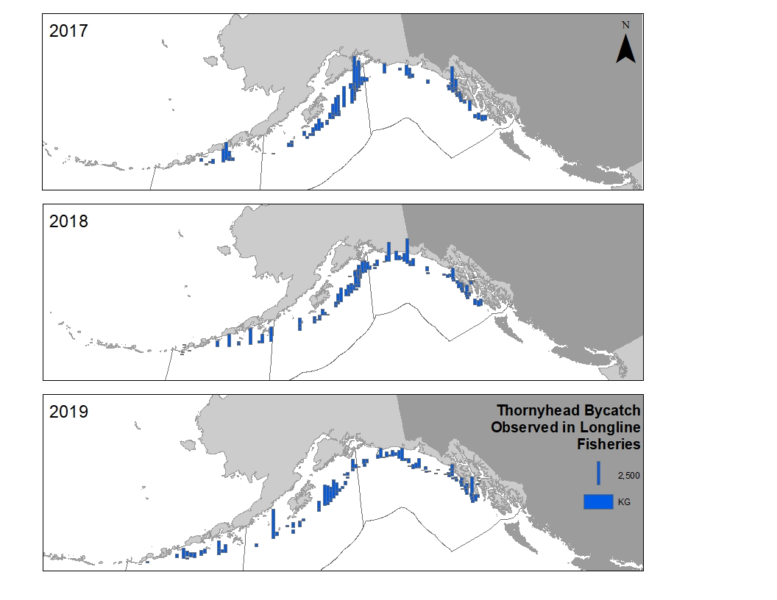

Figure 15-1.--

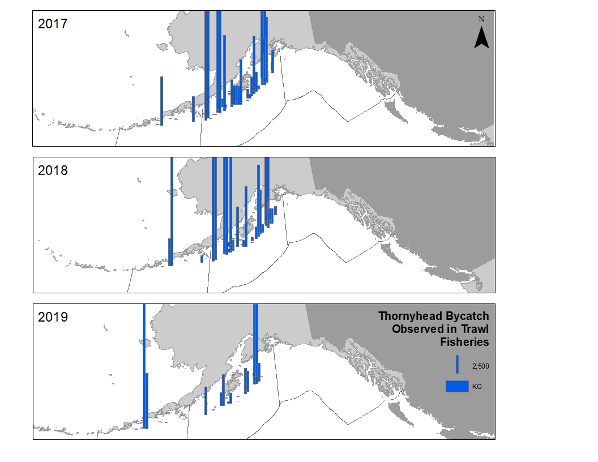

Figure 15-1.-- Spatial distribution of observed thornyhead rockfish catch in the longline fisheries (top three panels) and in the trawl fisheries (bottom three panels) in the GOA from 2017 – 2019. Height of the bar represents the catch in kilograms. Each bar represents non-confidential catch data summarized into 400km2 grids. Note that catch within the inside waters of Southeast are not within federal waters. Grid blocks with zero catch were not included for clarity. Data provided by the Fisheries Monitoring and Analysis division website, queried October 12, 2020 (https://www.fisheries.noaa.gov/resource/map/alaska-groundfish-fishery-observer-data-map).

Figure 15-2.--Shortspine thornyhead lengths measured in trawl and longline fisheries, 2017–2019. Note 2020 data is not shown as there weren’t enough samples collected.

Figure 15-3.--Shortspine thornyhead length frequencies from the NMFS longline survey, 2018–2020.

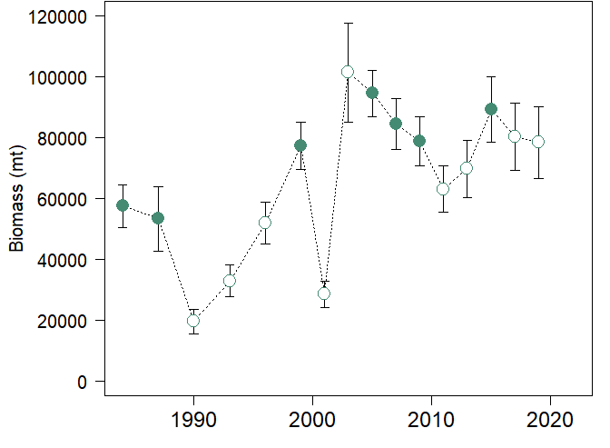

Figure 15-4.--Trawl survey biomass estimates for Gulf of Alaska (GOA) thornyhead rockfish. The 1990, 1993, 1996, and 2001 surveys did not survey depths >500 m. The 2003, 2011, 2013, 2017, and 2019 surveys did not survey depths >700 m. The 2001 survey also did not survey the Eastern GOA. The years with missing depth strata or regions are denoted by open circles.

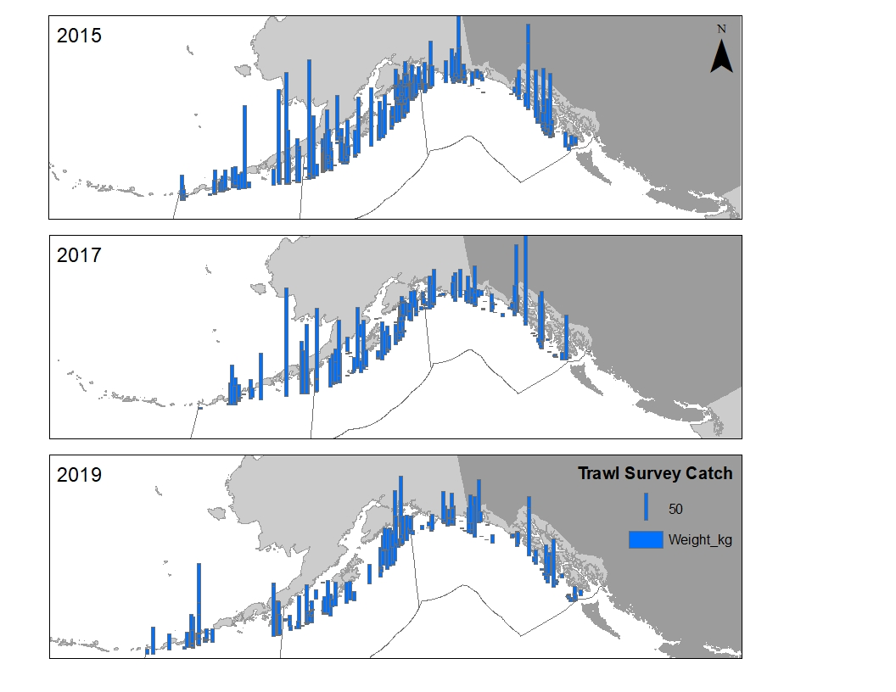

Figure 15-5.--Spatial distribution of thornyhead rockfish catches in the Gulf of Alaska 2015, 2017, and 2019 NMFS bottom trawl surveys.

Figure 15-6.--Shortspine thornyhead length frequencies from the 2015, 2017, and 2019 trawl surveys.

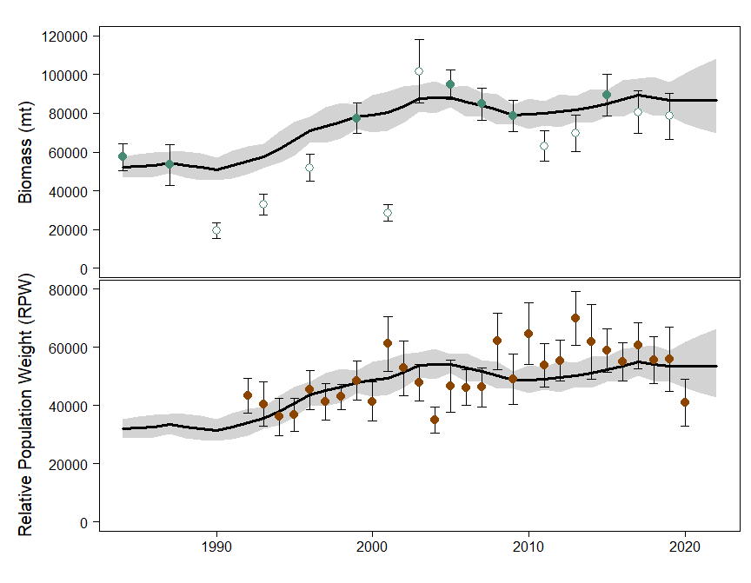

Figure 15-7.--Biomass estimates (t, top panel) of thornyhead rockfish from the random effects model (solid black line with 95% confidence interval in grey shaded region) for the AFSC bottom trawl survey (filled circle with error bars for 95% confidence intervals, open circles denotes years with missing regional/depth strata data), and Relative Population Weight estimates (RPW, lower panel) from the random effects model (solid black line with 95% confidence interval in grey shaded region) for the AFSC longline survey (filled circle with error bars for 95% confidence intervals).

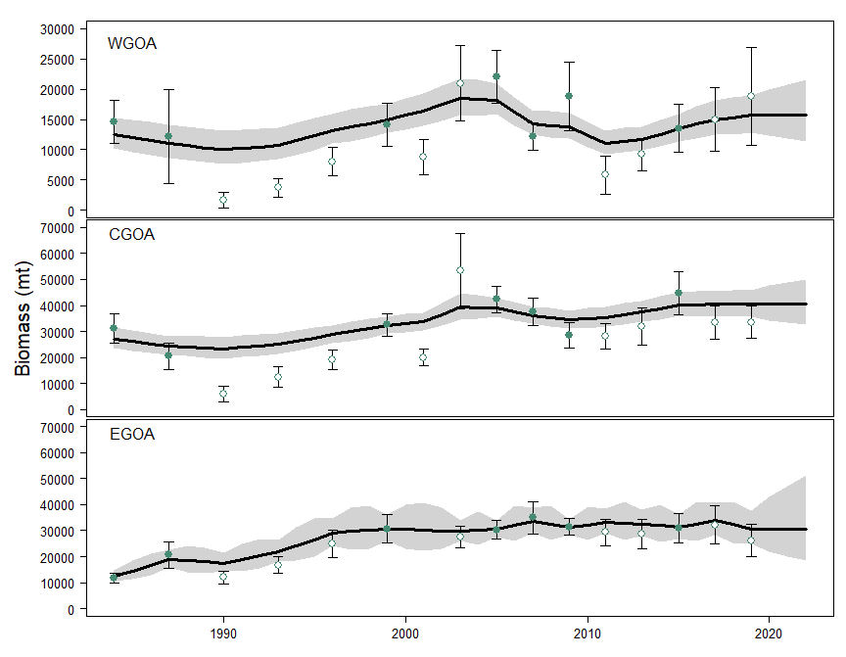

Figure 15-8.-- Biomass estimates (t) of thornyhead by area from NMFS bottom trawl surveys (filled circle with error bars for the 95% confidence intervals) fit to the recommended random effects model (solid black line with 95% confidence intervals shown in grey shaded region). Open circle points in the figure denote years with missing depth strata data. Top panel is the Western Gulf of Alaska (WGOA) area, middle panel is the Central Gulf of Alaska (CGOA) area, and bottom panel is the Eastern Gulf of Alaska (EGOA) area. Please note the different scales between panels on the y-axis.

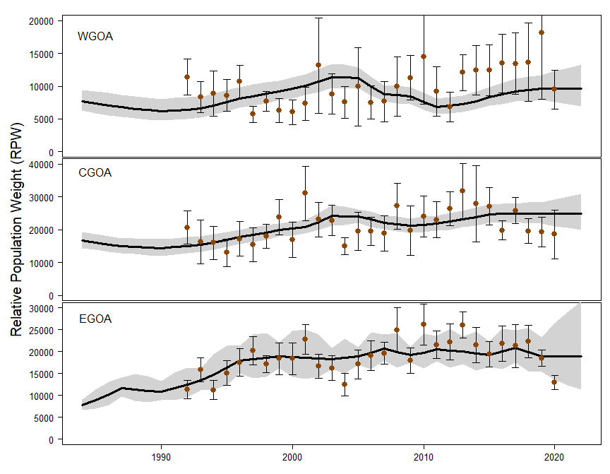

Figure 15-9.- - Relative Population Weight (RPW) of thornyhead by area from AFSC longline surveys (filled circle with error bars for the 95% confidence intervals) fit to the recommended random effects model (solid black line with 95% confidence intervals shown in grey shaded region). Please note the different scales between panels on the y-axis.

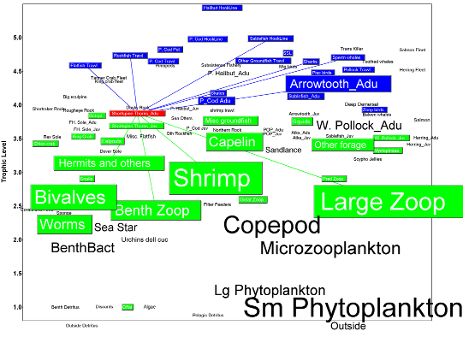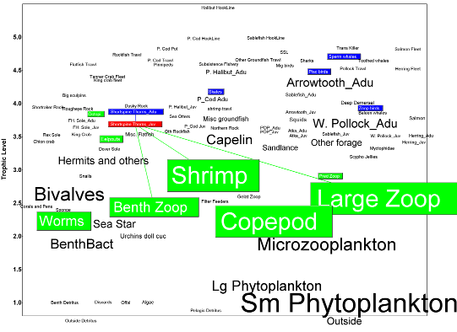

Figure 15-10.--Position of shortspine thornyheads within Gulf of Alaska food webs: adults (marked red in upper panel) and juveniles (marked red in lower panel). Groups shaded blue are predators of shortspine thornyheads, and groups shaded green are prey. Similar information for longspine thornyheads is not available.

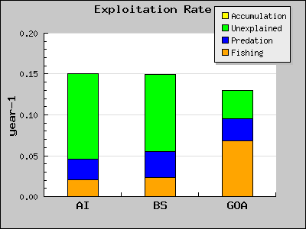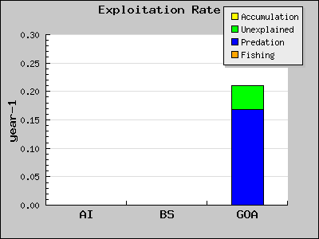

Figure 15-11.--Comparison of exploitation rates for shortspine thornyheads across Alaskan ecosystems. Adult shortspine thornyheads (upper panel) have higher predation than fishing mortality in the Aleutian Islands (AI) and Eastern Bering Sea (EBS), but higher fishing mortality in the Gulf of Alaska (GOA). Juvenile shortspine thornyheads (lower panel) were only modeled in the GOA, where they do not experience fishing mortality but do experience substantial predation mortality. Because juvenile thornyheads were not explicitly modeled in AI and EBS ecosystem models, juvenile mortality is included along with adult mortality in the top panel for AI and EBS, which exaggerates the differences between predation and fishing mortality between the two systems.

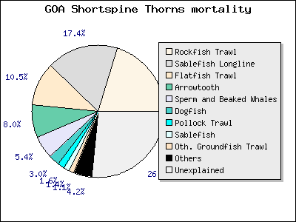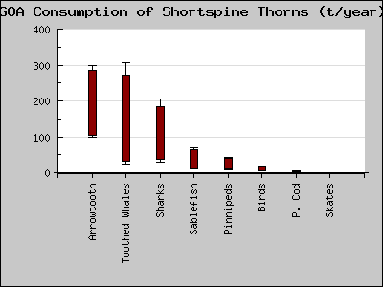

Figure 15-12.--Mortality sources (upper panel) and annual consumption in tons (lower panel) by predators of adult shortspine thornyheads in the Gulf of Alaska (GOA). Fisheries for rockfish, sablefish, and flatfish account for nearly 50% of total adult shortspine thornyhead mortality, while all predators combined account for about 25% of total mortality.

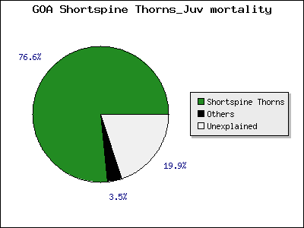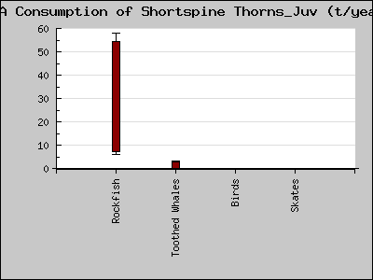

Figure 15-13.--Mortality sources (upper panel) and annual consumption in tons (lower panel) by predators of juvenile shortspine thornyheads in the Gulf of Alaska (GOA). “Rockfish” in the lower panel refers to adult thornyheads, which account for more than 75% of juvenile thornyhead mortality via cannibalism.

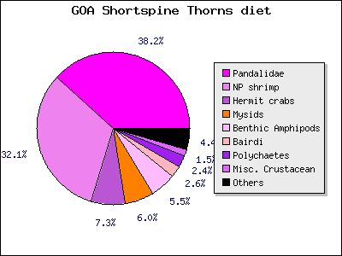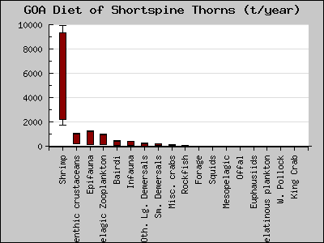

Figure 15-14.--Diet composition (upper panel) and annual consumption of prey in tons (lower panel) by adult shortspine thornyheads in the Gulf of Alaska (GOA).

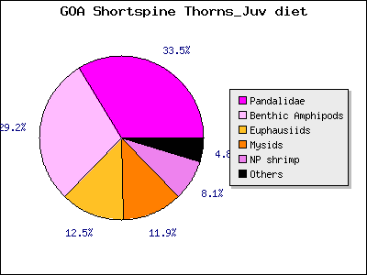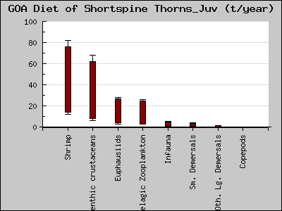

Figure 15-15.--Diet composition (upper panel) and annual consumption of prey in tons (lower panel) by juvenile shortspine thornyheads in the Gulf of Alaska (GOA).

# Appendix 15A – Supplemental catch data

In order to comply with the Annual Catch Limit (ACL) requirements, non-commercial removals in the Gulf of Alaska (GOA) are presented. Non-commercial removals are estimated total removals that do not occur during directed groundfish fishing activities (Table 15A-1). This includes removals incurred during research, subsistence, personal use, recreational, and exempted fishing permit activities, but does not include removals taken in fisheries other than those managed under the groundfish FMP. These estimates represent additional sources of removals to the existing Catch Accounting System estimates.

Research catches of thornyhead rockfish for the years 1977–2019 are listed in Table 15A-1. Although data are not available for a complete accounting of all research catches, the values in the table indicate that generally these catches have been modest. The majority of research removals of thornyhead rockfish are taken by the Alaska Fisheries Science Center’s (AFSC) annual longline survey. Other research activities that harvest minor amounts of thornyhead rockfish include other trawl research activities conducted by the AFSC and the Alaska Department of Fish and Game (ADFG), and the International Pacific Halibut Commission’s (IPHC) longline survey. There are no records of recreational harvest or harvest that was non-research related. The non-commercial removals show that a total of approximately 14 t of thornyhead rockfish was taken in 2019 during research cruises (Table 15A-1). This total is approximately 1.8% of the reported commercial catch of 777 t for thornyhead rockfish in 2019 (see Table 15-1 in the main document). Therefore, this presents no risk to the stock especially because commercial catches in recent years have been much less than ABCs.

Table 15A-1.--Research catches of GOA thornyheads (t), 1977–2019. Estimates from IPHC survey and “other” sources only available since 2010.

|  |  |  |  |  |  |  |
| --- | --- | --- | --- | --- | --- | --- |
| Year | Domestic Longline Survey | Trawl Survey | Japan US  Longline Survey | IPHC Survey | Other | Total research catch |
| 1977 |  | 1 |  |  |  | 1 |
| 1978 |  | 1 |  |  |  | 1 |
| 1979 |  | 5 | 3 |  |  | 8 |
| 1980 |  | 1 | 5 |  |  | 6 |
| 1981 |  | 10 | 5 |  |  | 14 |
| 1982 |  | 6 | 4 |  |  | 10 |
| 1983 |  | 1 | 4 |  |  | 5 |
| 1984 |  | 24 | 3 |  |  | 27 |
| 1985 |  | 12 | 4 |  |  | 16 |
| 1986 |  | 2 | 4 |  |  | 5 |
| 1987 |  | 17 | 4 |  |  | 20 |
| 1988 | 2 | 0 | 5 |  |  | 7 |
| 1989 | 3 | 0 | 5 |  |  | 8 |
| 1990 | 3 | 4 | 4 |  |  | 11 |
| 1991 | 4 |  | 3 |  |  | 7 |
| 1992 | 5 |  | 4 |  |  | 9 |
| 1993 | 5 | 5 | 4 |  |  | 14 |
| 1994 | 4 |  | 5 |  |  | 9 |
| 1995 | 5 |  |  |  |  | 5 |
| 1996 | 6 | 6 |  |  |  | 12 |
| 1997 | 6 |  |  |  |  | 6 |
| 1998 | 6 | 9 |  |  |  | 15 |
| 1999 | 6 | 23 |  |  |  | 29 |
| 2000 | 5 |  |  |  |  | 5 |
| 2001 | 7 | 2 |  |  |  | 9 |
| 2002 | 5 |  |  |  |  | 5 |
| 2003 | 5 | 7 |  |  |  | 12 |
| 2004 | 4 |  |  |  |  | 4 |
| 2005 | 5 | 9 |  |  |  | 14 |
| 2006 | 5 |  |  |  |  | 5 |
| 2007 | 5 | 9 |  |  |  | 14 |
| 2008 | 7 |  |  |  |  | 7 |
| 2009 | 6 | 7 |  |  |  | 13 |
| 2010 | 9 | <1 |  | <1 | <1 | 9 |
| 2011 | 10 | 4 |  | <1 | <1 | 14 |
| 2012 | 9 |  |  | <1 | <1 | 9 |
| 2013 | 13 | 4 |  | <1 | <1 | 17 |
| 2014 | 10 |  |  | <1 | <1 | 10 |
| 2015 | 10 | 8 |  | 0.5 |  | 18.5 |
| 2016 | 9 |  |  | <1 |  | 9 |
| 2017 | 11 | 5 |  | <1 |  | 16 |
| 2018 | 9 |  |  | <1 |  | 9 |
| 2019 | 9 | 4 |  | 1 | <1 | 14 |